 

**BLACKBUCKS INTERNSHIP REPORT**



**Building a real time small scale application (Mart) using various AWS services [11.8 tier Architecture]**

**SUBMITTED BY**

**Ms. CHITTURI GOWRI SRI VALLI RegdNo:21B91A5434**

**Ms. GUBBALA SAIDIVYA RegdNo:21B91A5457**

**Ms. NALLALA MOHANA LAKSHMI RegdNo:21B91A05L0**

**UNDER THE GUIDANCE OF**

**MR. AASHU DEV**

B.Tech, AWS solution Architect (2x) certified,

AWS Academy Accredited Educator



**Blackbuck Engineers Pvt, Ltd**

**Road No 36, Jubilee Hills, Hyderabad**

**BLACKBUCK INTERNSHIP WORK**

**Team Members:**

• **CHITTURI GOWRI SRI VALLI** (21B91A5434)

• **GUBBALA SAIDIVYA** (21B91A5457)

• **NALLALA MOHANA LAKSHMI** (21B91A05L0)

**Title:**

**Building a real time small scale application (Mart) using various AWS services [11.8 tier Architecture]**

**Abstract:**

An Architecture of real time small scale application of Mart. This project mainly focused on uploading, manipulating and stock piling of data. In the list of AWS services S3 provides us with an additional feature of storing the versions of data and this data is transferred to DynamoDB by removing the duplicates which is a serverless NO SQL database for fast and flexible data. In this process a messaging service SNS is used to alert the subscribers on exceeding or lagging behind the specified threshold. Now RDS is the next entry of data for the high availability and for a promising purpose of backing up the statistics.

**Table of Contents**

1. Introduction to Cloud Computing 4-7
2. Why AWS? 8
3. Difference between Traditional IT and Modern IT 9
4. AWS Global Infrastructure 10-12
5. List of top AWS Services 12-21
6. Implementation of real time appilication (Mart) 22

Using various AWS Services

6.1. Introduction 22

6.2. AWS services used 23

6.3. AWS subservices used 23

6.4. Rough Architecture 24

6.5. Final architecture 25

7. Implementation of the project 26

7.1. Service 1: VPC 26-34

7.1.1. Sub Service: Routes

7.1.2. Sub Service: Internet gateway

7.1.3. Sub Service: Peering Connection

7.2. Service 2: EC2 34-40

7.2.1. Sub Service: AMI

7.3. Service 3: S3 41-42

7.4. Service 4: Lambda 42-51

7.4.1. Sub Service: Trigger

7.5. Service 5: DynamoDB 51-55

7.6. Service 6: CloudWatch 56-58

7.7. Service 7: SNS 58-61

7.8. Service 8: ELB 62-67

7.8.1. Sub Service: Boot Strapping

7.9. Service 10: RDS 68-69

7.10. Service 11: AWS Glue 69-72

7.10.1. Sub Service: Crawler

7.11. Service 12: IAM 73-74

7.11.1. Sub Service: IAM User

8. Conclusion

**What is Cloud Computing?**

Cloud computing is the on-demand delivery of IT resources over the Internet with pay-as-you-go pricing. Instead of buying, owning, and maintaining physical data centers and servers, you can access technology services, such as computing power, storage, and databases, on an as-needed basis from a cloud provider like Amazon Web Services (AWS). 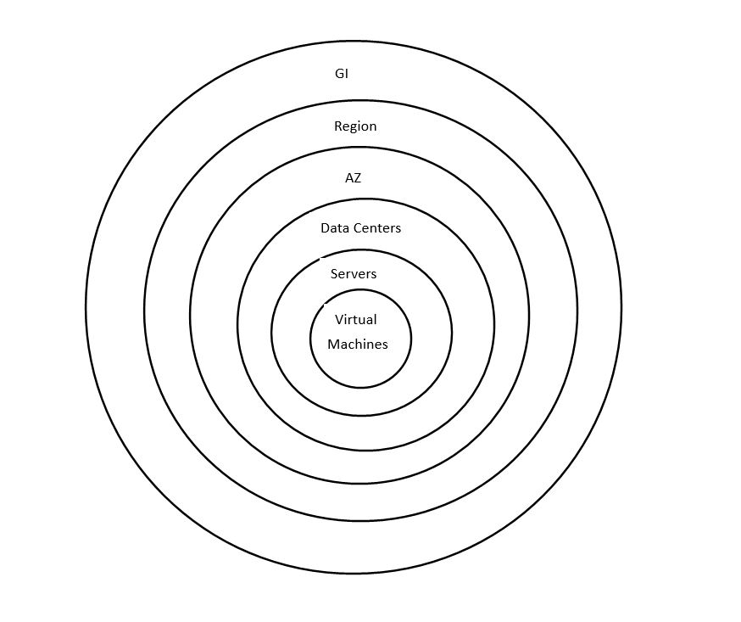

**Who is using cloud computing?**

Organizations of every type, size, and industry are using the cloud for a wide variety of use cases, such as data backup, disaster recovery, email, virtual desktops, software development and testing, big data analytics, and customer-facing web applications. For example, healthcare companies are using the cloud to develop more personalized treatments for patients. Financial services companies are using the cloud to power real-time fraud detection and prevention. And video game makers are using the cloud to deliver online games to millions of players around the world.

**Benefits of cloud computing**

* **Agility:**

The cloud gives you easy access to a broad range of technologies so that you can innovate faster and build nearly anything that you can imagine. You can quickly spin up resources as you need them–from infrastructure services, such as compute, storage, and databases, to Internet of Things, machine learning, data lakes and analytics, and much more.You can deploy technology services in a matter of minutes, and get from idea to implementation several orders of magnitude faster than before. This gives you the freedom to experiment, test new ideas to differentiate customer experiences, and transform your business.

* **Elasticity:**

With cloud computing, you don’t have to over-provision resources up front to handle peak levels of business activity in the future. Instead, you provision the amount of resources that you actually need. You can scale these resources up or down to instantly grow and shrink capacity as your business needs change.

* **Cost Savings:**

The cloud allows you to trade fixed expenses (such as data centers and physical servers) for variable expenses, and only pay for IT as you consume it. Plus, the variable expenses are much lower than what you would pay to do it yourself because of the economies of scale.

* **Deploy globally in minutes:**

With the cloud, you can expand to new geographic regions and deploy globally in minutes. For example, AWS has infrastructure all over the world, so you can deploy your application in multiple physical locations with just a few clicks. applications in closer proximity to end users reduces latency and improves their experience.

**Features of Cloud Computing**

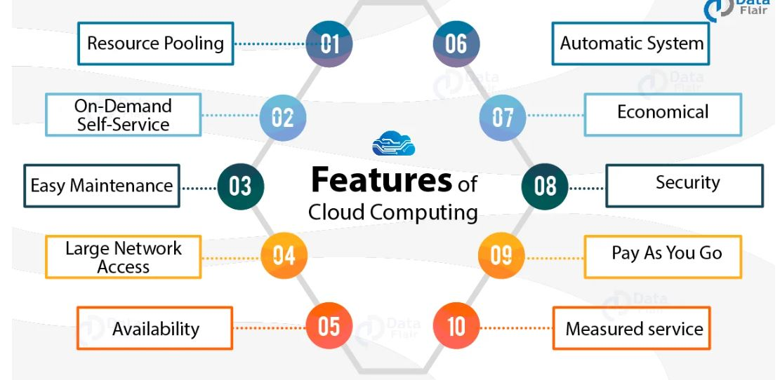

### **1. Resources Pooling**

It means that the **Cloud provider** pulled the computing resources to provide services to multiple customers with the help of a multi-tenant model. There are different physical and virtual resources assigned and reassigned which depends on the demand of the customer.

The customer generally has no control or information over the location of the provided resources but it is able to specify location at a higher level of abstraction

### **2. On-Demand Self-Service**

It is one of the important and valuable features of Cloud Computing as the user can continuously monitor the server uptime, capabilities, and allotted network storage. With this feature, the user can also monitor the computing capabilities.

### **3. Easy Maintenance**

The servers are easily maintained and the downtime is very low and even in some cases, there is no downtime. Cloud Computing comes up with an update every time by gradually making it better.

The updates are more compatible with the devices and perform faster than older ones along with the bugs which are fixed.

### **4. Large Network Access**

The user can access the data of the cloud or upload the data to the cloud from anywhere just with the help of a device and an internet connection. These capabilities are available all over the network and accessed with the help of internet.

### **5. Availability**

The capabilities of the Cloud can be modified as per the use and can be extended a lot. It analyzes the storage usage and allows the user to buy extra **Cloud storage** if needed for a very small amount.

### **6. Automatic System**

Cloud computing automatically analyzes the data needed and supports a metering capability at some level of services. We can monitor, control, and report the usage. It will provide transparency for the host as well as the customer.

### **7. Economical**

It is the one-time investment as the company (host) has to buy the storage and a small part of it can be provided to the many companies which save the host from monthly or yearly costs. Only the amount which is spent is on the basic maintenance and a few more expenses which are very less.

### **8. Security**

**Cloud Security**, is one of the best features of cloud computing. It creates a snapshot of the data stored so that the data may not get lost even if one of the servers gets damaged.

The data is stored within the storage devices, which cannot be hacked and utilized by any other person. The storage service is quick and reliable.

### **9. Pay as you go**

In cloud computing, the user has to pay only for the service or the space they have utilized. There is no hidden or extra charge which is to be paid. The service is economical and most of the time some space is allotted for free.

### **10. Measured Service**

Cloud Computing resources used to monitor and the company uses it for recording. This resource utilization is analyzed by supporting charge-per-use capabilities.

**Cloud computing with AWS** Amazon Web Services (AWS) is the world’s most comprehensive and broadly adopted cloud, offering over 200 fully featured services from data centers globally. Millions of customers—including the fastest-growing startups, largest enterprises, and leading government agencies—are using AWS to lower costs, become more agile, and innovate faster.

**Why aws?**

## 

## **Easy to use**

AWS is designed to allow application providers, ISVs, and vendors to quickly and securely host your applications – whether an existing application or a new SaaS-based application. You can use the AWS Management Console or well-documented web services APIs to access AWS’s application hosting platform

## 

## **Flexible**

## AWS enables you to select the operating system, programming language, web application platform, database, and other services you need. With AWS, you receive a virtual environment that lets you load the software and services your application requires. This eases the migration process for existing applications while preserving options for building new solutions.

## **Cost-Effective**

You pay only for the compute power, storage, and other resources you use, with no long-term contracts or up-front commitments. For more information on comparing the costs of other hosting alternatives with AWS, see the AWS Economics Center.

## 

## **Reliable**

With AWS, you take advantage of a scalable, reliable, and secure global computing infrastructure, the virtual backbone of Amazon.com’s multi-billion dollar online business that has been honed for over a decade.

## 

## **Scalable and high-performance**

Using AWS tools, Auto Scaling, and Elastic Load Balancing, your application can scale up or down based on demand. Backed by Amazon’s massive infrastructure, you have access to compute and storage resources when you need them.

## 

## **Secure**

AWS utilizes an end-to-end approach to secure and harden our infrastructure, including physical, operational, and software measures. For more information, see the AWS Security Center.

**Difference Between Traditional IT and Modern IT:**

|  |  |  |
| --- | --- | --- |
| **Aspect** | **Traditional Information Technology** | **Modern Information Technology** |
| Hardware | Relied on physical servers and on-premises data centers. | Embraces virtualization, cloud computing, and edge computing. |
| Software | Primarily installed locally on individual machines. | Utilizes web-based applications and software as a service (SaaS). |
| Data Storage | Local storage on physical hard drives or network-attached storage. | Cloud-based storage solutions with scalable options. |
| Connectivity | Limited by physical cabling and local networks. | High-speed internet and wireless connectivity enable global reach. |
| Scalability | Scaling up required significant hardware investments and time. | Easily scalable using cloud services, allowing quick adjustments to resources. |
| Security | Relied on firewalls and on-premises security measures. | Utilizes advanced encryption, multi-factor authentication, and AI-driven security. |
| Maintenance | Regular on-site maintenance and updates were necessary. | Automated updates and maintenance through the cloud. |
| Cost | High upfront costs for hardware and licenses. | More flexible pricing models with pay-as-you-go options. |
| Accessibility | Limited access to systems from outside the office. | Enables remote access and collaboration from anywhere with an internet connection. |
| Mobility | Limited mobility, tied to physical machines and locations. | Facilitates mobile workforce with access to data on various devices. |
| Analytics and Big Data | Basic data analysis with limited processing capabilities. | Harnesses big data analytics and AI for advanced insights and decision-making. |
| User Experience | Often involved manual processes and less intuitive interfaces. | Focuses on user-centric design and seamless experiences. |
| Integration and Interoperability | Interconnected systems were complex to set up. | Embraces open APIs and standards for seamless integration of various applications. |

**AWS Global Infrastructure**

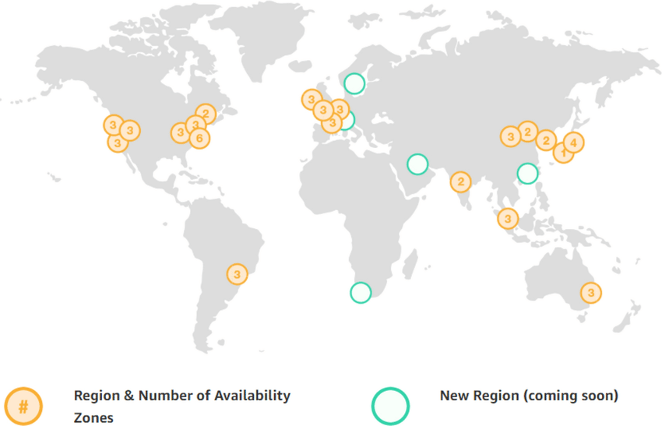

The AWS Global Cloud Infrastructure is the most secure, extensive, and reliable cloud platform, offering over 200 fully featured services from data centers globally. Whether you need to deploy your application workloads across the globe in a single click, or you want to build and deploy specific applications closer to your end-users with single-digit millisecond latency, AWS provides you the cloud infrastructure where and when you need it.With millions of active customers and tens of thousands of partners globally, AWS has the largest and most dynamic ecosystem. Customers across virtually every industry and of every size, including start-ups, enterprises, and public sector organizations, are running every imaginable use case on AWS.

**Components of Global Infrastructure:**

The following are the components that make up the AWS infrastructure:

• Availability Zones

• Region

• Edge locations

• Regional Edge Cache

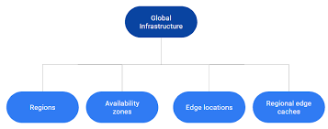

**Availability zone as a Data Center**

• An availability zone is a facility that can be somewhere in a country or in a city. Inside this facility, i.e., Data Centre, we can have multiple servers, switches, load balancing, firewalls. The things which interact with the cloud sit inside the data centers.

• An availability zone can be a several data centers, but if they are close together, they are counted as 1 availability zone.

**Region**

• A region is a geographical area. Each region consists of 2 more availability zones.

• A region is a collection of data centers which are completely isolated from other regions.

• A region consists of more than two availability zones connected to each other through links.

• Availability zones are connected through redundant and isolated metro fibers.

**Edge Locations**

• Edge locations are the endpoints for AWS used for caching content.

• Edge locations consist of CloudFront and Amazon's Content Delivery Network (CDN).

• Edge locations are more than regions. Currently, there are over 150 edge locations.

• Edge location is not a region but a small location that AWS have. It is used for caching the content.

• Edge locations are mainly located in most of the major cities to distribute the content to end users with reduced latency.

• For example, some user accesses your website from Singapore; then this request would be redirected to the edge location closest to Singapore where cached data can be read

**Regional Edge Cache**

• AWS announced a new type of edge location in November 2016, known as a Regional Edge Cache.

• Regional Edge cache lies between CloudFront Origin servers and the edge locations.

• A regional edge cache has a larger cache than an individual edge location.

• Data is removed from the cache at the edge location while the data is retained at the Regional Edge Caches.

• When the user requests the data, then data is no longer available at the edge location. Therefore, the edge location retrieves the cached data from the regional edge cache instead of the Origin servers that have high latency.

**List of top AWS Services:**

AWS is the widely used cloud platform worldwide, from start-ups to large enterprises. Though AWS services were introduced to the market by 2006, their revenue from Public Cloud SaaS has hit 145.5 billion USD by 2021. Presently, Amazon Web Services are a one-stop solution for all cloud services ranging from data storage to analytics. AWS services provide easy, simple, costeffective cloud services, which drive businesses to achieve increased efficiency and performance. Besides, these services have many more features to serve customers in multiple ways.

Now, let's have a look at the most popular AWS services in 2023. In this blog, you can learn what is the objective, features, and benefits of each AWS service.

Here is the list of Top 30 AWS Services List:

**1.Amazon EC2 [Elastic Compute Cloud]:**

Amazon EC2 is one of the fastest-growing cloud computing AWS services, which offers virtual servers to manage any kind of workload. It facilitates the computing infrastructure with the best suitable processors, networking facilities, and storage systems. As a result, it supports adapting to the workloads precisely. Amazon EC2 provides a highly secure, reliable, performing computing infrastructure meeting business demands. And it helps you to access resources quickly and dynamically scale capacities as per demands.



**2. Amazon S3:**

Another popular addition to the AWS services list is Amazon S3, which is an object storage AWS service, which is highly scalable. It mainly helps users to access any quantity of data from anywhere. Here, data is stored in ‘storage classes’ to reduce costs without any extra investment and manage it comfortably. The data is highly secure and supports meeting audit and compliance requirements. You can handle any volume of data with Amazon S3’s robust access controls, replication tools, and higher visibility. Moreover, it supports maintaining data version controls and preventing accidental deletion



3**. AWS Aurora:**

Amazon Aurora is the next addition to this list of top AWS services in demand. Why? It is a MySQL and PostgreSQL compatible relational database with high performance. Believe it or not, it is five times faster than standard MySQL databases. And it allows for automating crucial tasks such as hardware provisioning, database setup and backups, and patching. Amazon Aurora is a distributed, fault-tolerant, self-healing storage system that could scale automatically as per needs. Besides, you can even reduce costs significantly and enhance databases' security, availability, and reliability.

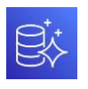

**4. Amazon DynamoDB:**

DynamoDB is a promising addition to this list of AWS services. DynamoDB is a fully managed and serverless NoSQL database AWS service. And it is a fast and flexible database system that provides innovative opportunities to developers at low costs. It gives you single-digit millisecond performance with unlimited throughput and storage. DynamoDB has in-built tools to generate actionable insights, useful analytics, and monitor traffic trends in applications

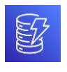

**5. Amazon RDS:**

Amazon RDS would be the next entry in this discussion on AWS services. Amazon RDS is the managed Relational Database AWS Service (RDS) for MySQL, PostgreSQL, Oracle, SQL Server, and MariaDB. It allows the setup, operation, and scale of a relational database in the cloud quickly. Also, it achieves high performance by automating the tasks such as hardware provisioning, database setup, patching, and backups. When you use Amazon RDS, you don’t need to install and maintain the database software. Overall, you can optimize costs by embracing this service and achieve high availability, security, and compatibility for your resources.

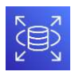

**6. Amazon Lambda:**

AWS Lambda is also a promising addition to the list of AWS services. Amazon Lambda is a serverless and event-driven computing AWS service. It helps to run codes automatically without worrying about servers and clusters. Simply put, codes can be uploaded directly to run without worrying about provisioning or managing infrastructure. So, this service automatically accepts code execution requests' irrespective of its scale. Besides, you can pay the price only for the computer time, so AWS Lambda makes effective cost-control



**7. Amazon VPC :**

Amazon VPC is the Virtual Private Cloud, which is an isolated cloud resource. It controls the virtual networking environment, such as resource placement, connectivity, and security. And it allows you to build and manage compatible VPC networks across cloud AWS resources and onpremise resources. Here, it improves security by applying rules for inbound and outbound connections. Also, it monitors VPC flow logs delivered to Amazon S3 and Amazon Cloudwatch to gain visibility over network dependencies and traffic patterns. Amazon VPC also detects anomalies in the patterns, prevents data leakage, and troubleshoots network connectivity and configuration issues

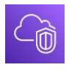

**8. Amazon CloudFront:**

Amazon CloudFront is another credible mention in the list of renowned Amazon Web Services. This AWS service delivers content globally, which offers high performance and security. Mainly, it delivers data with high speed and low latency. Here, content is delivered to destinations successfully with automated network mapping and intelligent routing mechanisms. The security of data is enhanced with traffic encryption methods and access controls. Also, data can be transferred within milliseconds with its in-built data compression, edge computing capabilities, and field-level encryption. Besides, you gear up streaming high-quality video using AWS media services to any device quickly and consistently using Amazon CloudFront.



**9. AWS Elastic Beanstalk**:

This AWS service supports running and managing web applications. Elastic Beanstalk allows for the easy deployment of applications from capacity provisioning, load balancing, and autoscaling to application health monitoring. With its auto-scaling properties, this service simplifies demands in scaling to adjust to the needs of the business. It helps to manage peaks in workloads and traffic with minimum costs. Basically, AWS Elastic Beanstalk is a developer-friendly tool since it manages servers, load balancers, firewalls, and networks simply. As a result, this service allows developers to show much more focus on coding.



**10. Amazon EC2 Auto-scaling:**

This AWS service scales computing capacity to meet the demands accurately. And it is achieved by adding or removing EC2 instances automatically. There are two types of scaling such as dynamic scaling and predictive scaling. Here, dynamic scaling responds to the presently changing demands, whereas predictive scaling responds based on predictions. Through Amazon EC2 Auto-scaling, you can identify the unhealthy EC2 instances, terminate them, and replace them with new instances.



**11. Amazon ElastiCache**:

Amazon ElastiCache is a fully managed, flexible, in-memory caching AWS service. It supports increasing the performance of your applications and database. And this service helps to reduce the load in a database by caching data in memory. Amazon ElastiCache accesses data from inmemory with high speed, microsecond latency, and high throughput. With a self-managed cache service, you can reduce costs and eliminate the operational overhead of your business.



**12. Amazon S3 Glacier**:

Amazon S3 Glacier is the archive storage in the cloud at a low cost. It is built with three storage classes such as S3 Glacier instant retrieval, flexible retrieval, and deep archive. Here, the instant class supports immediate access to data, and the flexible class allows flexible access within minutes to hours with no cost. The third one, deep archive, helps archive compliance data and digital media. Overall, they support you to access data from archives faster.



**13. Amazon LightSail**:

Amazon LightSail is the website and applications building AWS service. This service offers Virtual Private Server instances, containers, databases, and storage. It allows a serverless computing service with AWS Lambda. With Amazon LightSail, you can create websites using pre-configured applications such as WordPress, Magento, Prestashop, and Joomla in a few clicks and at a low cost. In addition to this, it is the best tool for testing, so you can create, test, and delete sandboxes with your new ideas



**14. Amazon Sagemaker**:

Amazon Sagemaker is the AWS service that allows building, training, and deploying Machine Learning (ML) models at a large capacity. It is an analytical tool that functions based on Machine Learning power to analyze data more efficiently. With its single toolset, you can build high-quality ML models quickly. Amazon Sagemaker not only generates reports but provides the purpose

for generating predictions too. In addition, Amazon Ground Truth Plus creates datasets without labeling applications.



**15. Amazon SNS**:

It is the Amazon Simple Notification Service (SNS). It is a messaging service between Application to Application (A2P) and Application to Person (A2Person). Here, A2P helps many-to-many messaging between distributed systems, microservices, and event-driven serverless applications. And A2P supports applications to send messages to many users via mail, SMS, etc. For instance, you can send up to ten messages in a single API request. With effective filtering systems, subscribers will receive messages that they are interested in. Besides, Amazon SNS works alongside Amazon SQS to deliver messages accurately and consistently



**16. Amazon EBS:**

Amazon Elastic Block Store (EBS) is a block storage service. It supports scaling highperformance workloads such as SAP, Oracle, and Microsoft products. And it provides better 14 protection against failures up to 99.999%. It helps to resize clusters for big data analytics engines such as Hadoop and Spark. Also, you can build storage volumes, optimize storage performance, and reduce costs. Amazon EBS’s lifecycle management creates policies that help create and manage backups effectively.

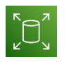

**17. Amazon Kinesis**:

It is the AWS service that analyses video as well as data streams. Amazon Kinesis collects, processes, and analyzes all types of streaming data. Here, the data may be audio, video, application logs, website clickstreams, and IoT telemetry. Then, it generates real-time insights within seconds once the data has arrived. With the help of Amazon Kinesis, you could stream and process a large quantity of real-time data with low latencies, very simply.



**18. Amazon Elastic File System (EFS)**:

Amazon EFS is the fully managed file system for Amazon EC2. And it is a simple and serverless elastic file system. You can create and configure file systems without provisioning, deploying, patching, and maintenance using Amazon EFS. Here, files can be added and deleted as per the scaling needs. Especially, you can pay only for the used space, hence this service helps to reduce costs



**19. AWS IAM**:

It is the Identity and Access Management (IAM) service offered by AWS to securely access the applications and resources. It regulates access to various resources based on roles and access policies; as a result, you can achieve a fine-grained access control on your resources. The AWS IAM access analyzer helps streamline permission management through setting, verifying, and refining. In addition, AWS IAM attribute-based access control helps create fine-grained permissions based on user attributes such as department, job role, team name, etc



**20. Amazon SQS**:

Amazon SQS is a fully managed message queuing service. There are two types of message queuing services: SQS Standard and SQS FIFO. Here, the SQS standard offers features such as maximum throughput, best-effort ordering, and quick delivery. And SQS FIFO processes messages only once in the same order by which they have been sent. Also, Amazon SQS allows decoupling or scaling microservices, distributed systems, and serverless applications. It helps you send, receive, and manage messages in a large volume. Moreover, there is no need to install and maintain other messaging software, reducing costs significantly. Besides, scaling is carried out quickly and automatically in this service.



**21. Amazon RedShift**:

Amazon Redshift is a quick, simple, and cost-effective data warehousing service. You can gain insights about cloud data warehousing in an easy, faster, and more secure way. It allows analysis of all the data in operational databases, data lakes, data warehouses, and third-party data. And Amazon Redshift helps analyze a large volume of data and run complex analytical queries. With its automation capabilities, this service increases query speed and provides the best price performance.

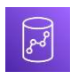

**22. Amazon Cloudwatch**:

This AWS service monitors the cloud resources and applications keenly. It is a single platform that helps to monitor all AWS resources and applications; it increases visibility to respond to issues quickly. Mainly, Amazon Cloudwatch provides actionable insights to optimize monitoring applications, systemwide performance changes, and resource utilization. And you can get a complete view of the health of AWS resources, applications, and services running on AWS and on-premises. In addition, Amazon CloudWatch helps to detect anomalies in the behavior of the cloud environment, set alarms, visualize logs and metrics, make automated actions, troubleshoot issues, and discover insights.



**23. Amazon Chime** :

Amazon Chime is a communication service. It is a single solution that offers audio calling, video calling, and screen sharing capabilities. With the help of this service, you can make quality meetings, chat, and video calls both inside and outside of your organization. And more features can be added to this service as per your business needs. Mainly, you can set calls for a predefined time to automatically make calls on time. Amazon Chime helps you not to miss a meeting amidst your hectic schedule at work. Besides, you can pay as per the usage of resources by which you can reduce the costs significantly.



**24. Amazon Cognito**:

It is the identity management AWS service. Amazon Cognito manages identities for accessing your applications and resources. Mainly, this service helps to add sign-in, sign-up, and access control the web and mobile apps quickly. It can support millions of users to sign in with familiar applications such as Apple, Facebook, Google, and Amazon. In Amazon Cognito, the feature ‘Cognito user pools’ can be set up quickly without any infrastructure, and the pool members will have a directory profile. It supports multi-factor authentication and encryption of data-at-rest and data-in-transit



**25. Amazon Inspector** :

Amazon Inspector is an automated vulnerability management service. This service offers continuous and automated vulnerability management for Amazon EC2 and Amazon ECR. It allows scanning AWS workloads for software vulnerabilities and unwanted network exposure. Amazon Inspector quickly identifies vulnerabilities, which helps to take immediate actions to resolve them before it worsens the applications. Moreover, it supports meeting compliance requirements and reduces meantime-to-remediate vulnerabilities. And it provides you with accurate risk scores and streamlined workflow



**26. AWS Firewall Manager**:

It is the central management service of firewall rules. The firewall manager supports managing firewall rules across all the applications and accounts. The common security rules help to manage new applications included over time. It is the one-time solution for consistently creating firewall rules and security policies and implementing them across the infrastructure. AWS firewall manager helps you audit VPC security groups for compliance requirements and control network traffic effectively.



**27. Amazon Appflow** :

Amazon Appflow is a no-code service that allows the integration of SaaS applications and AWS services effortlessly. To be more precise, it securely automates dataflows integrating third-party applications and AWS services without using codes. You can transfer data between SaaS applications such as Salesforce, SAP, Zendesk, etc. since Amazon Appflow can be integrated with other applications in a few clicks. Especially, a large volume of data can be moved without breaking it up into batches using this service.



**28. Amazon Route 53**:

It is a scalable cloud Domain Name System (DNS) service. It allows end-users to connect with Amazon EC2, Elastic load balancers, Amazon S3 buckets, and even outside AWS. In this service, the feature ‘Route 53 application recovery controllers’ configure DNS health checks and helps to monitor the ability of systems to recover from failures. And ‘Route 53 traffic flow’ helps manage traffic across the globe using routing methods such as latency-based routing, Geo DNS, Geoproximity, and weighted round-robin



**29. AWS Cloud Formation**:

This AWS service creates and manages resources with templates. It is a single platform that can handle all AWS accounts across the globe. It automates resource management with AWS service integration and offers turnkey application distribution and governance controls. Also, AWS Cloud Formation can automate, test, and deploy infrastructure with continuous integration and delivery. And you can run applications right from AWS EC2 to complex multi-region applications using this service



**30. AWS Key Management Service (KMS)** :

AWS KMS manages the creation and control of encryption keys. It means that AWS KMS creates cryptographic keys and controls their uses across various applications. You can achieve a secure and resilient service using hardware resilient modules to protect keys. This service can be integrated with AWS Cloudtrail to provide logs of all key usage to precisely fulfil compliance and regulatory requirements.



**Implementation of real time application (Mart) using various AWS services.**

***Introduction:***

A Small Scale Application (Mart):

In Real time managing the data is the crucial task for any industrialist. So we designed an application which deals with large datasets to get better of five dimensions of Big Data (5v’s). Including interconnectivity to stay tuned with regular customers and consumers.

Central Principal and Mechanism:

As for the principal, our main goal is to be in charge of organizing the data collected from various branches of a mart. We first establish two arms in same region and in different availability zones. Now we place two S3 buckets in these zones one in each. Now we gather and reflect the customer logs onto every bucket. Now we eliminate the twin data and transport the sole data into DynamoDb as permanent records for forthcoming. As this data can be only used for overall estimate we transport the data from S3 to RDS so that we can query the data as per our necessity.

Roles of AWS Services in Crafting the Architecture:

* Create VPC’s and launch EC2 Instances using AMI and create two buckets in each zone.
* Now we attach Lambda Trigger to S3 buckets.
* After that we Import data from S3 in DynamoDB.
* Now we redirect to CloudWatch by viewing the read metrics and erecting the Alerts.
* Now these Alert messages are sent to specified customers using SNS.
* As a back up storage we pile up the data in RDS using Glue by attaching an IAM role on behalf of glue for RDS full access.

**AWS Services Used:**

1. ***Virtual Private Cloud(VPC)***
2. ***Elastic Compute Cloud(EC2)***
3. ***Simple Storage Service(S3)***
4. ***Lambda***
5. ***Identity and Access Management(IAM)***
6. ***Cloud watch***
7. ***Simple Notification Service(SNS)***
8. ***DynamoDB***
9. ***Elastic Load Balancer(ELB)***
10. ***Glue***
11. ***Relational Database Service(RDS*)**

**AWS Subservices Used:**

1. *Internet Gateway*
2. *Peering Connections*
3. *Amazon Machine Images(AMI)*
4. *Elastic Ips*
5. *Trigger*
6. *IAM Users*
7. *Crawlers*
8. *Boot Strapping*

**Rough Architecture**

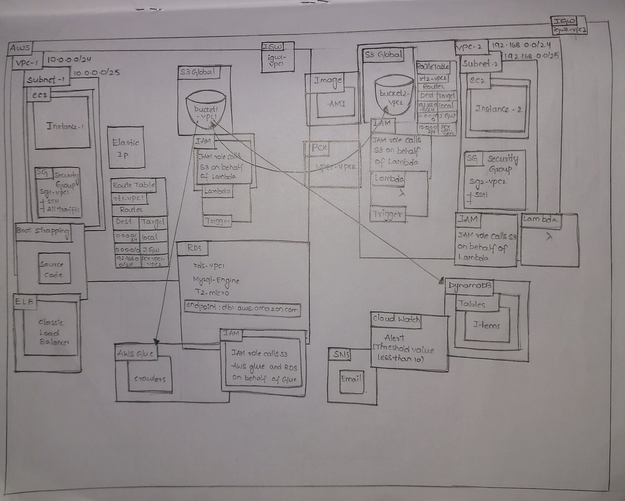

**Final Architecture**

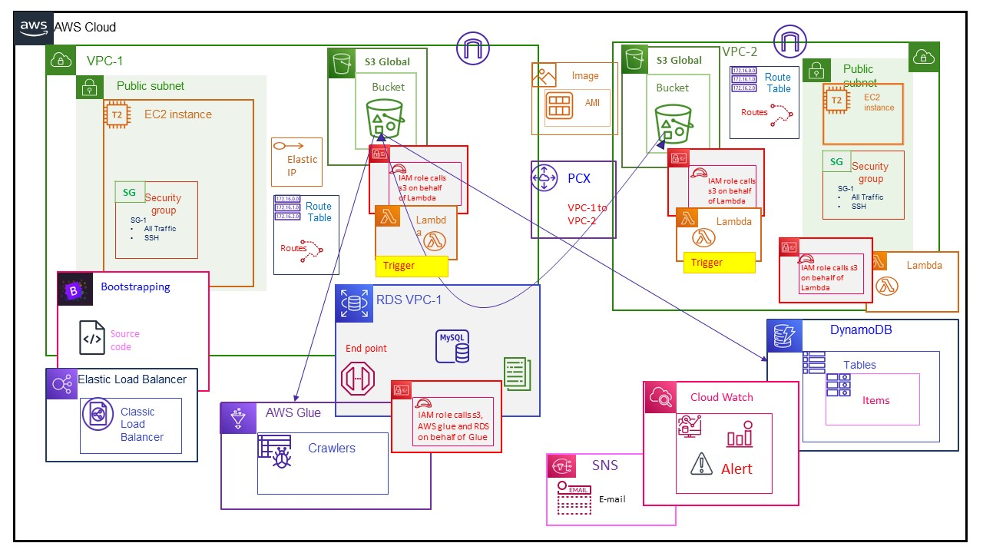

**Implementation of the Project**

Service 1: VPC



To create 2 VPCs with the name "VPC1,VPC2" follow these steps:

* Sign into the AWS Management Console.
* Open the Virtual Private Cloud Service.
* Click on the "Create VPC" option.
* Give the first VPC name as vpc1 and CIDR value as 10.0.0.0/24
* Click on create VPC.
* Similarly create the second VPC name as vpc2 and CIDR value as 192.168.0.0/24
* Click on create VPC

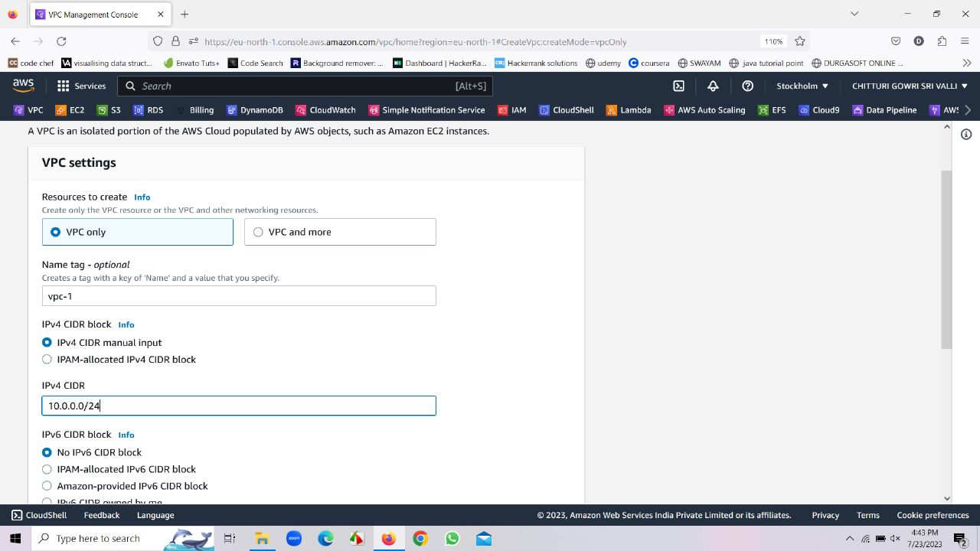

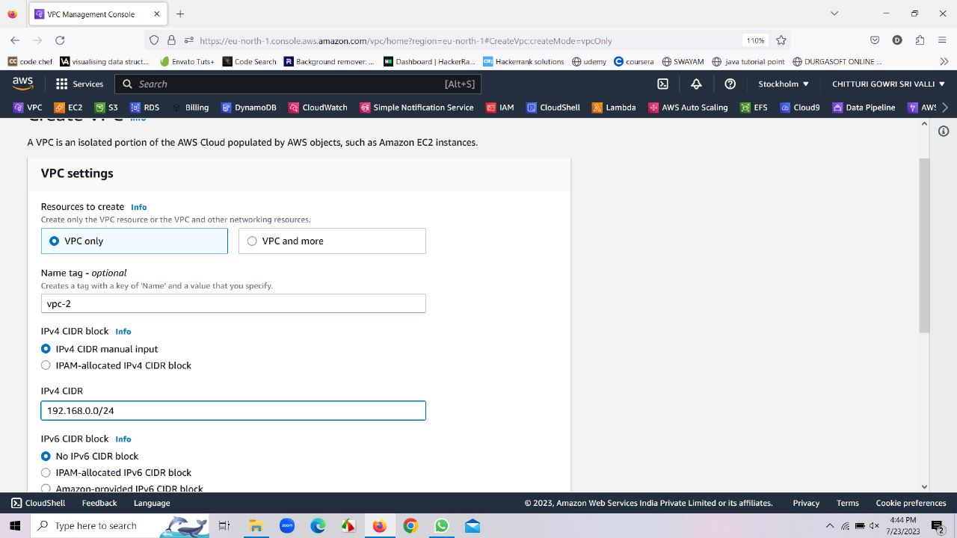

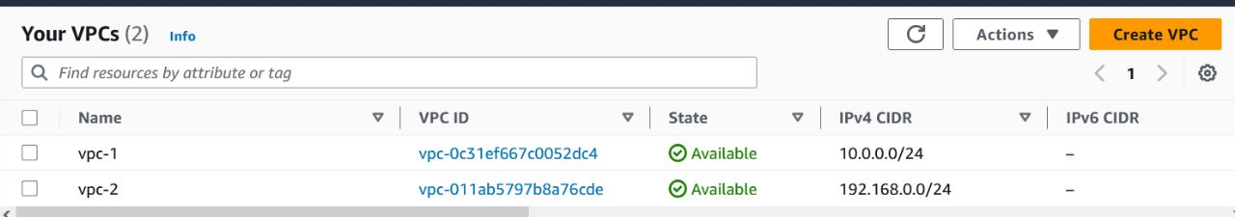

* Go to route table and edit the name of route table as rt1-vpc1 that is created along with vpc1.
* Go to route table and edit the name of route table as rt2-vpc2 that is created along with vpc2.

**Sub Service: Route Tables**

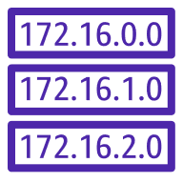

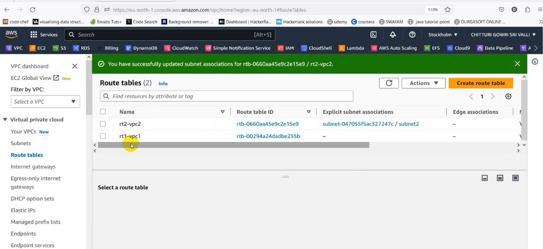

* Go to subnets and create a subnet and name it as subnet1. Select the availability zone as eu-north-1a, CIDR as 10.0.0.0/25 and select create subnet
* Similarly create an another subnet with name subnet2. Select the availability zone as eu-north-1a, CIDR as 192.168.0.0/25 and select create subnet

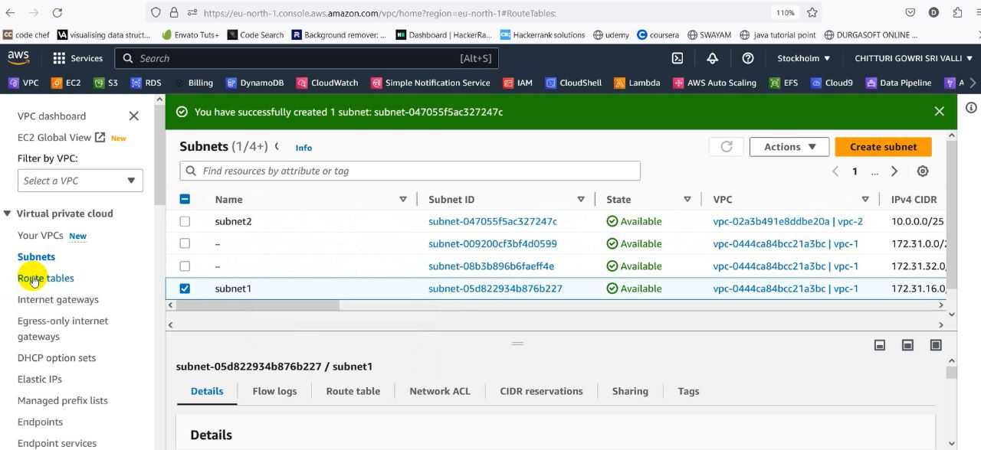

• Go to route tables, select the each route table, and go to subnet associations and select its subnet and click on save associations.

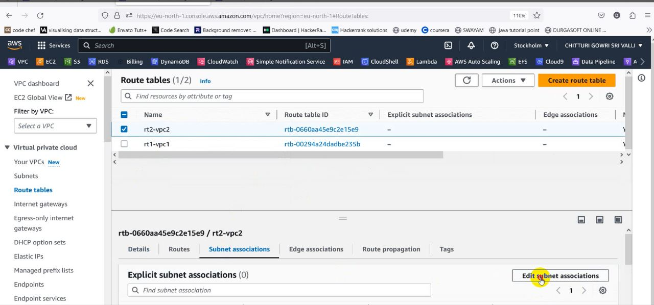

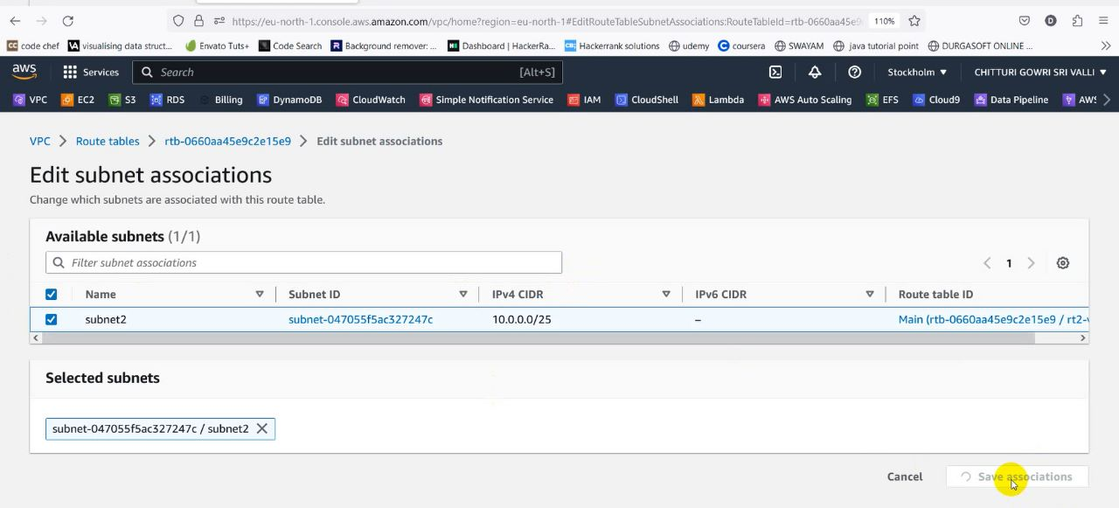

* Create an internet gateways with the name igw1-vpc1
* Create another internet gateway with the name igw2-vpc2

**Sub Service: Internet Gateway**



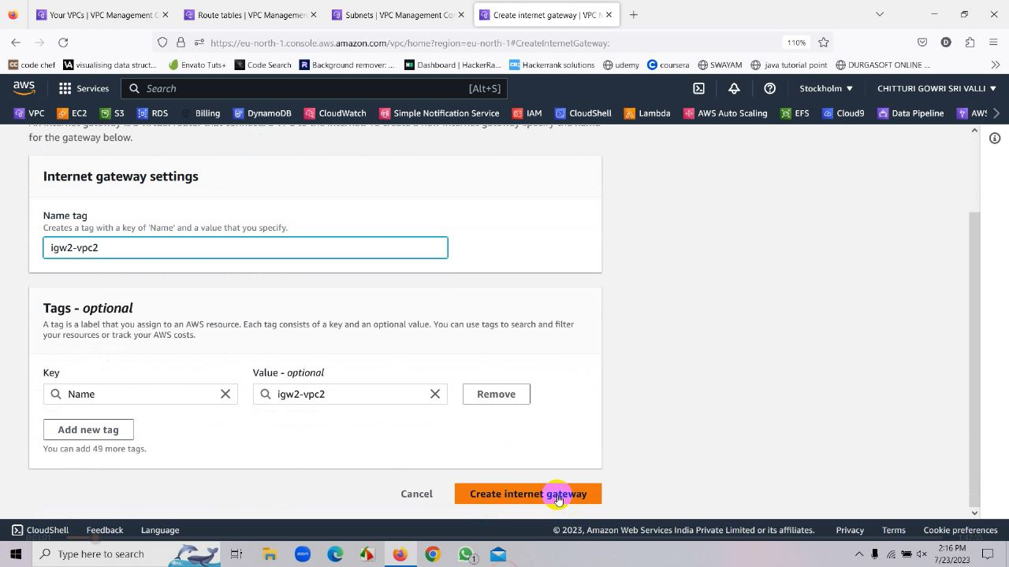

• Attach custom IGWs to custom VPC

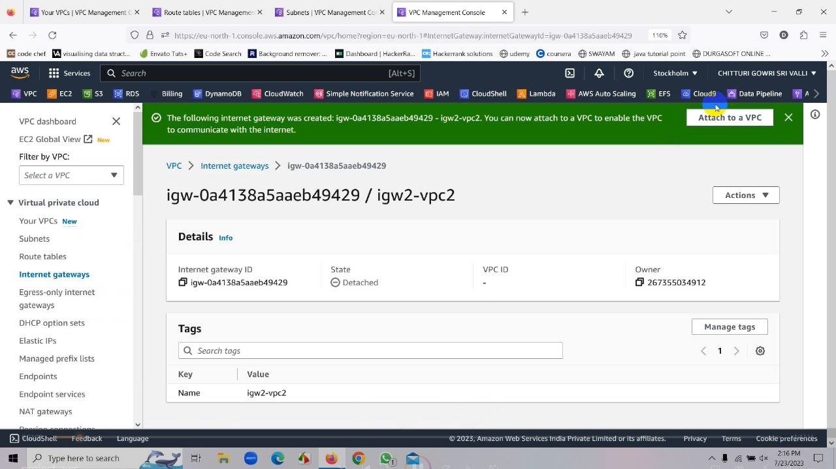

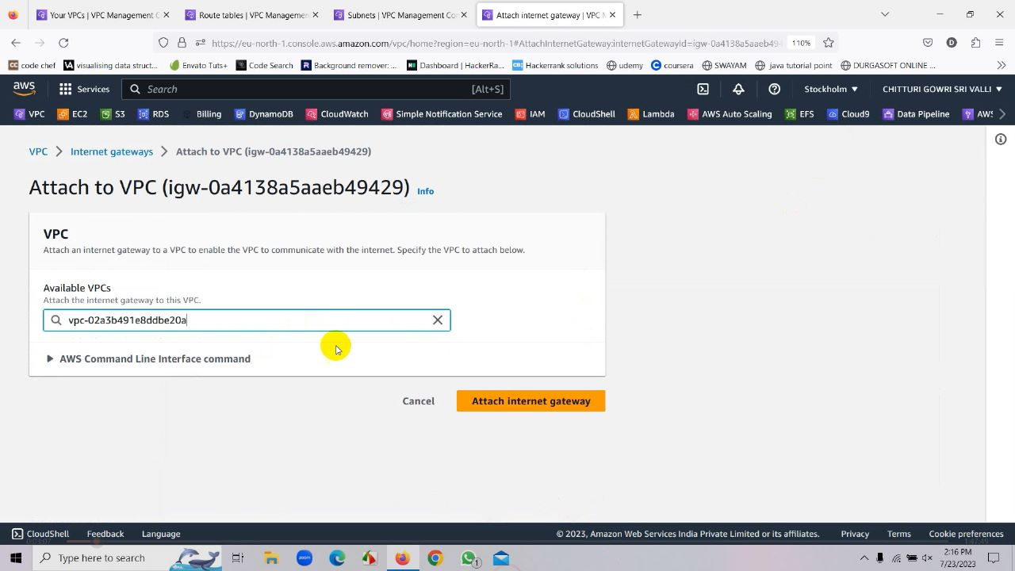

* Internet Gate Way is successfully attached to VPC
* Now go to route tables, select rt1-vpc1, click on edit routes, go to add routes, and add 0.0.0.0/0 at destination and select our internet gateway in destination and save it
* 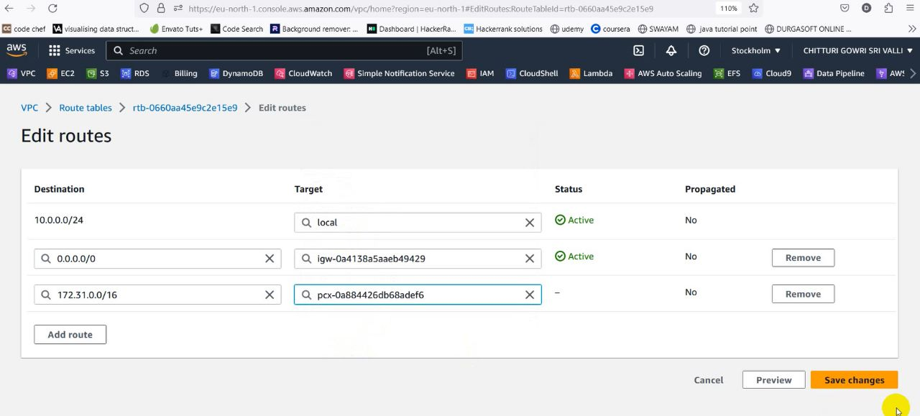Similarly do the same process for the route rt2-vpc2
* Now go to Peering Connection and give the name as vpc1-vpc2 and create a peering connection

**Sub Service: Peering Connection**



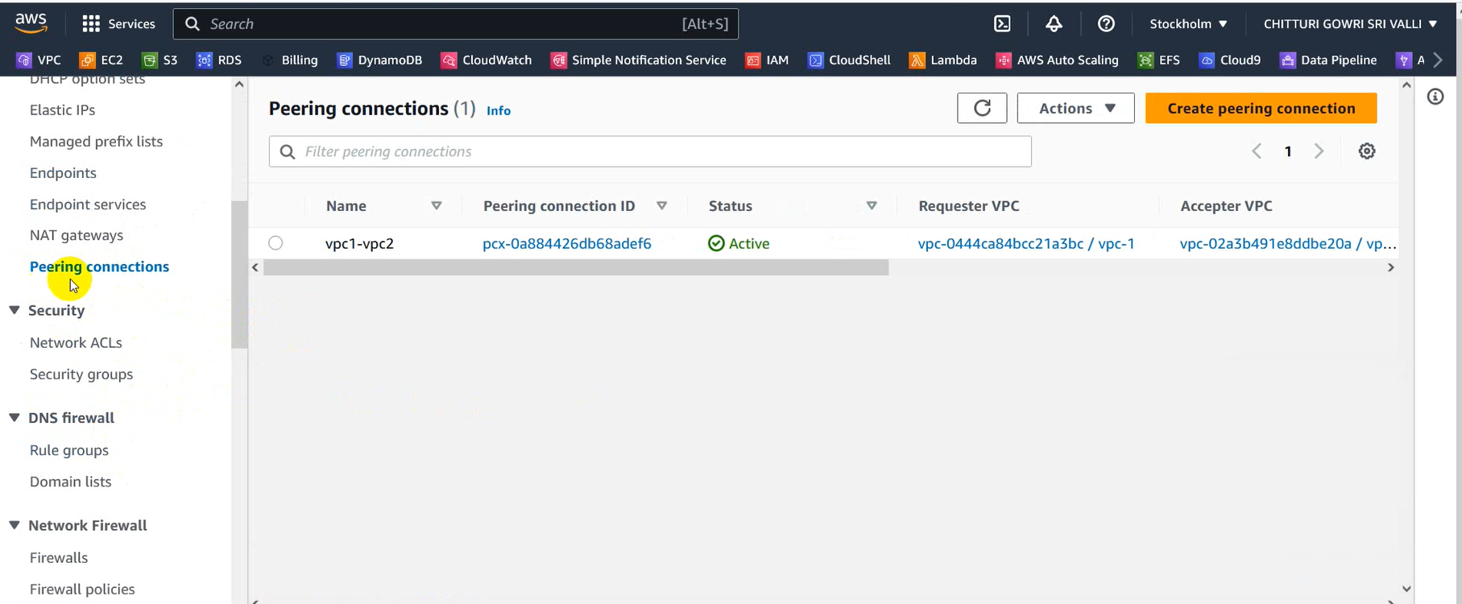

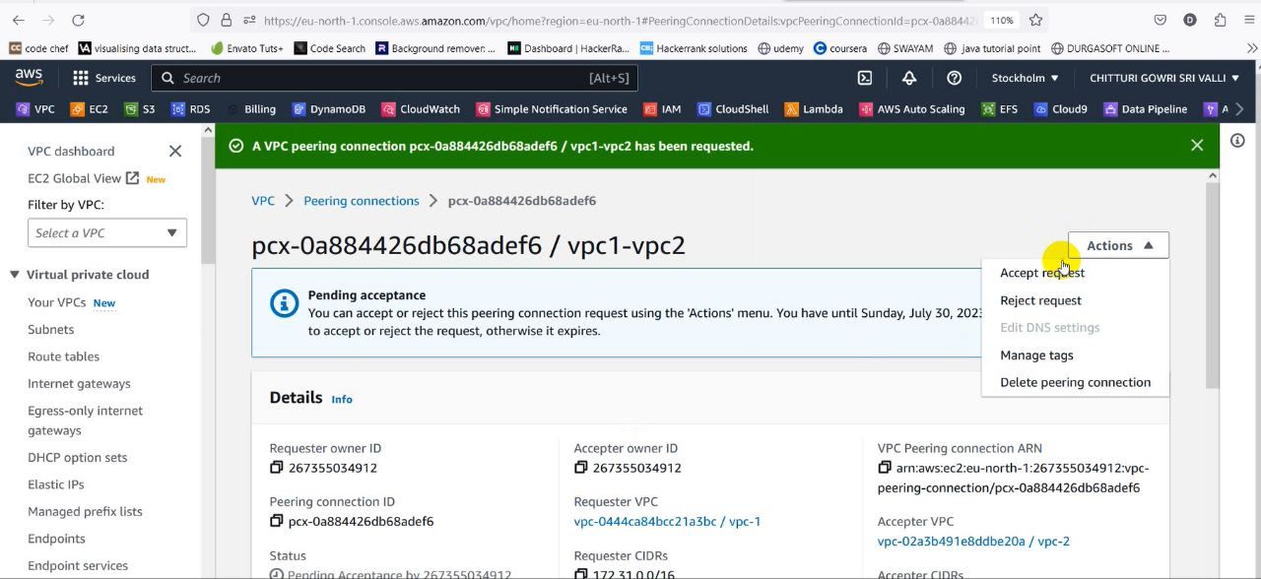

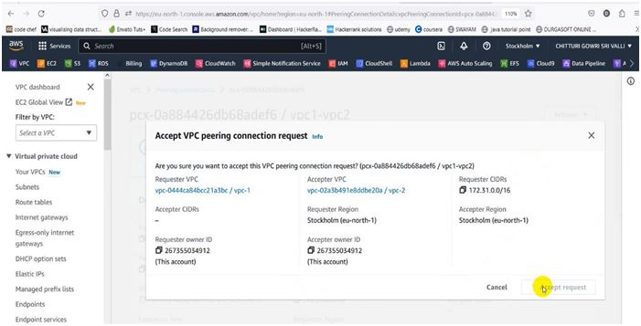

* Go to route tables, select rt1-vpc1,click on edit routes, go to add routes, and add 192.168.0.0/24 at destination and select our peering connection in destination and save it
* Execute the same process for rt2-vpc2 by adding 10.0.0.0/24 at destination and select our peering connection in destination and save it



**Service 2:EC2**



Click on Launch your instance

• Name your instance as vm1-vpc

• Select “Amazon Linux 2 AMI”.

• Instance type “t3. micro”.

• Select your existing key pair.

• Select your custom VPC, public subnet and enable the auto-assign public IP.

•In the security group section, select availability zone as eu-north-1a.

• create a new security group, add security groups that supports SSH and all the traffic

• Launch your instance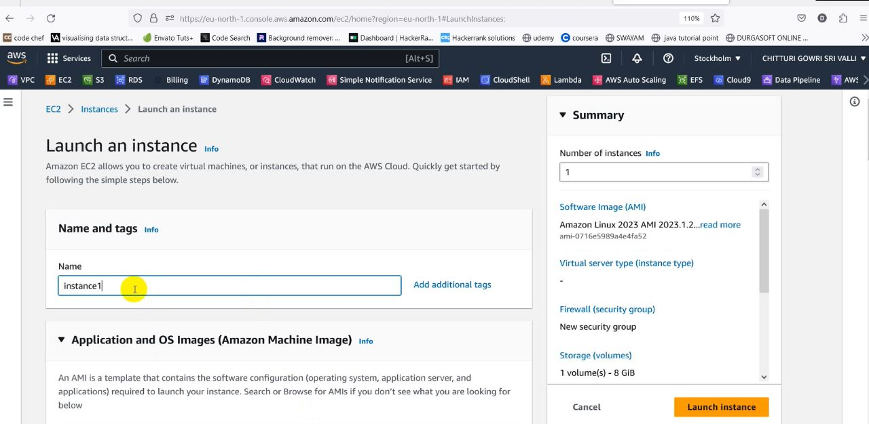

• Here we name the instance as “instance1”.

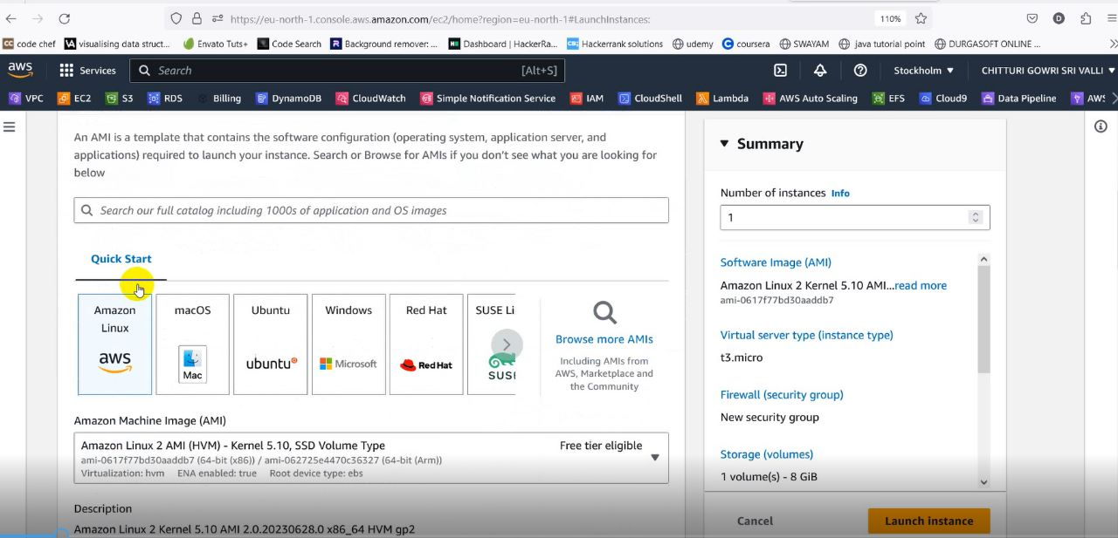

• We choose “Amazon Linux 2 AMI(HVM) – Kernel 5.10.SSD Volume Type in AMI

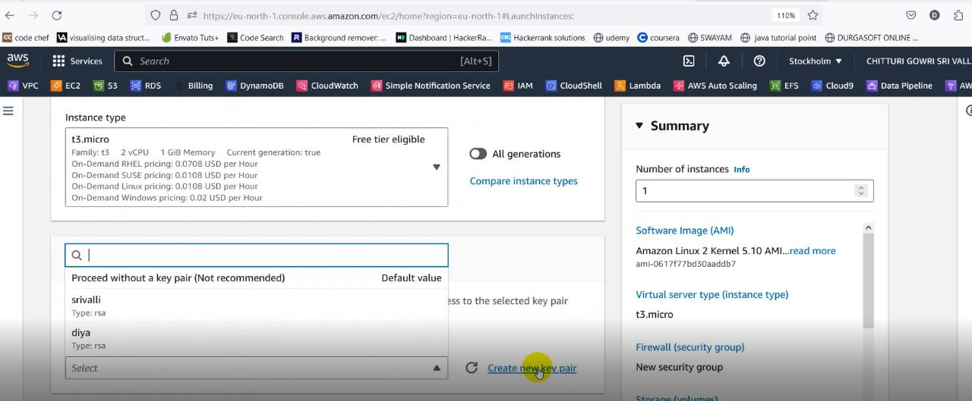

* Here we selected the key pair srivalli

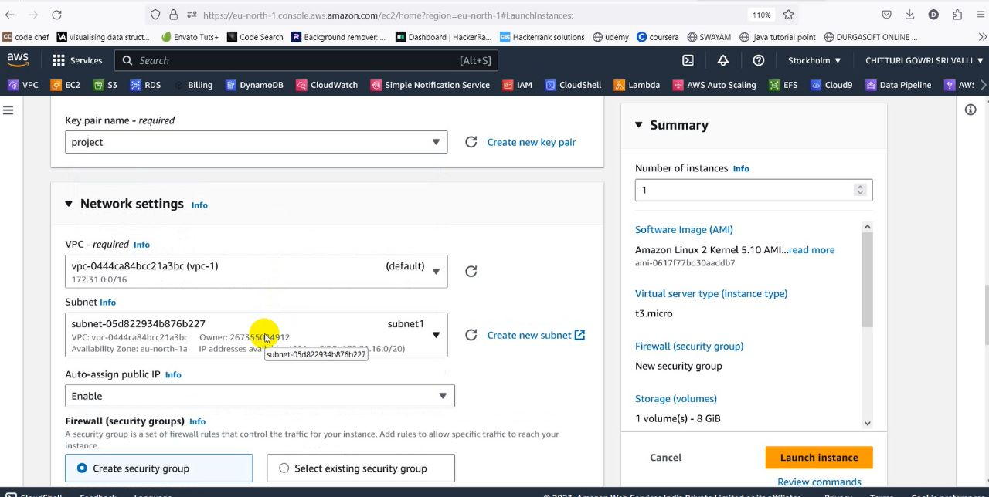

* We have selected the availability zone as eu-north-1a

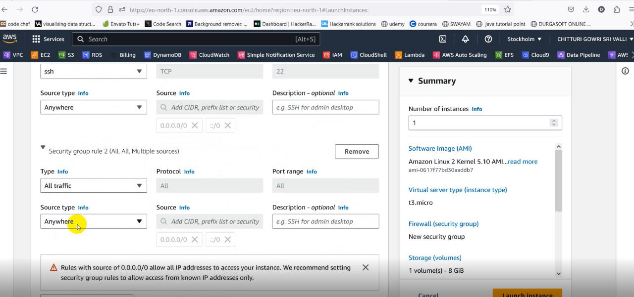

• Add “Type: All traffic”,” source type: Anywhere” in in bound security Group rules.

* In advanced details, click on the upload file and upload the following code

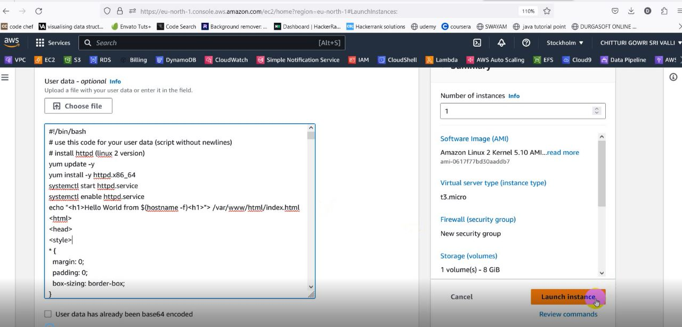

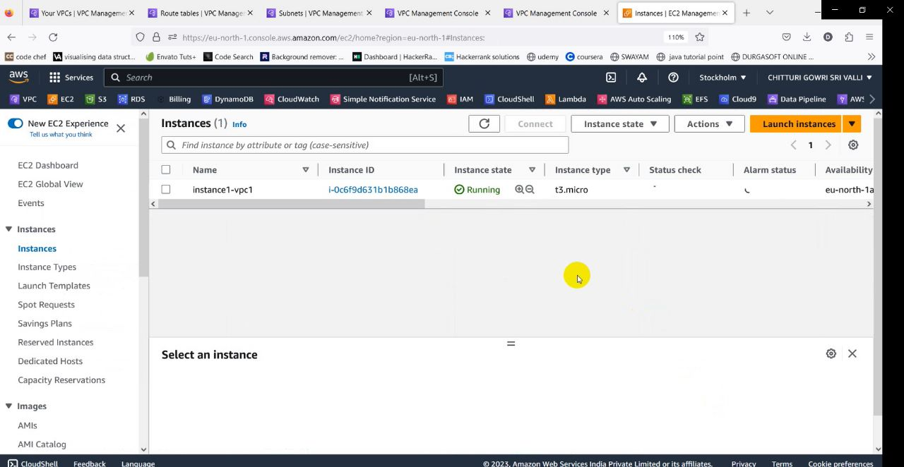

* Now “instance-1” is successfully launched.

**Sub Service: AMI**



• Select the instance-1

• Go to action.

• Go to image and templates.

• Click on create image, give image name, and create the image

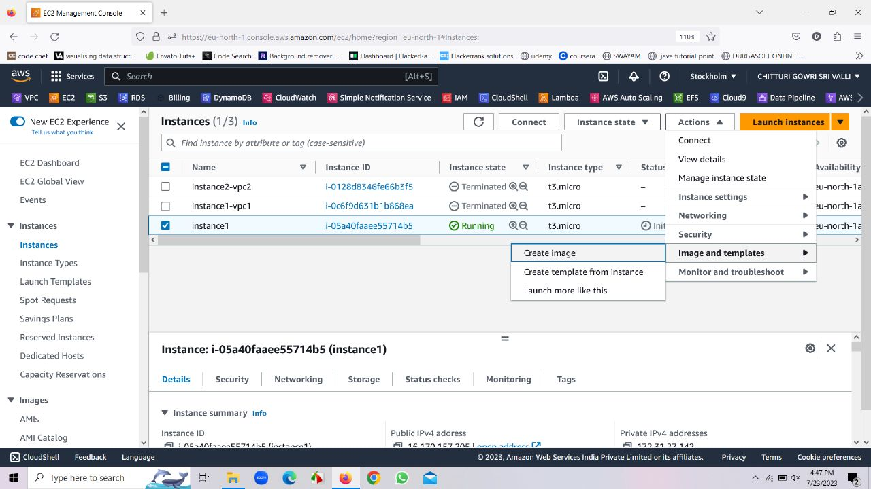

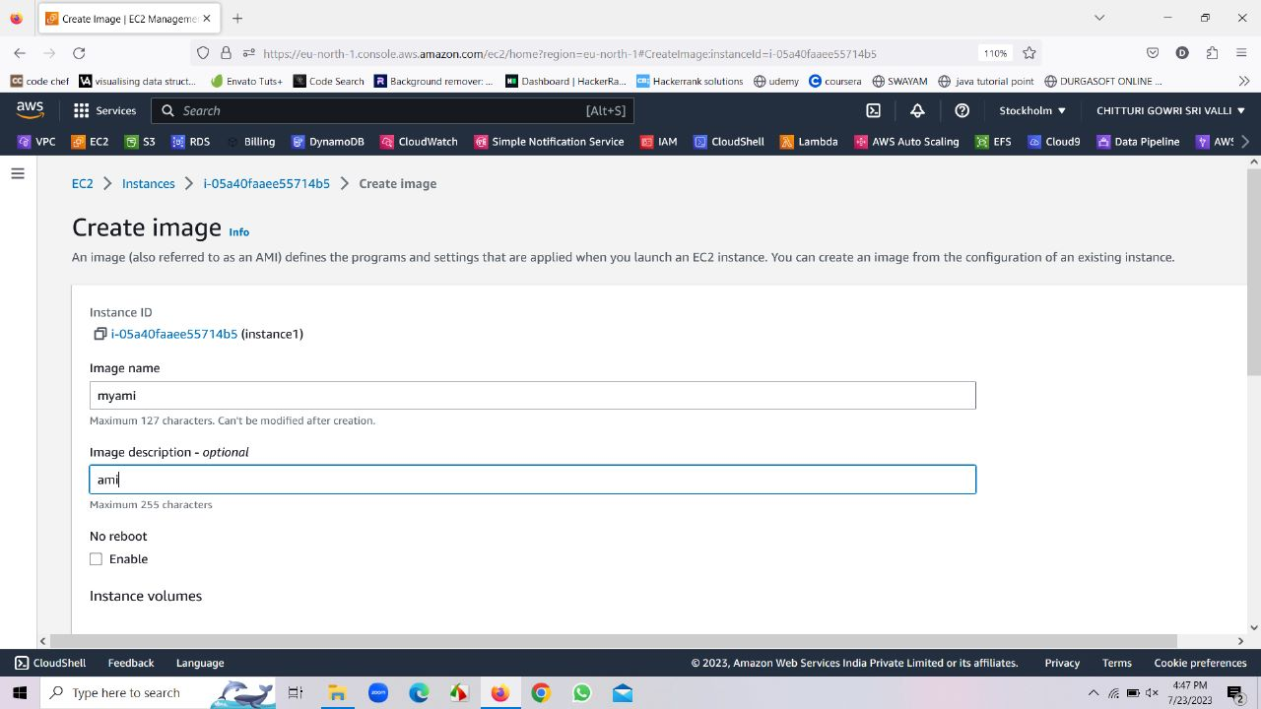

• After images have been created go to AMI, there we can find an AMI

. • Whenever an AMI is created a snapshot gets created along with it

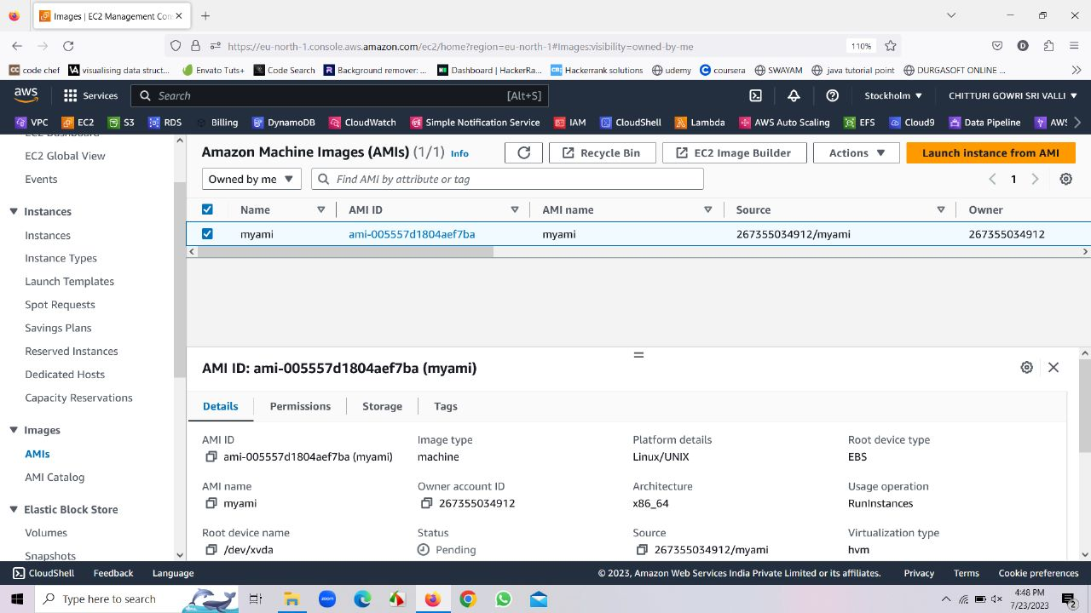

* Now click on launch instance from AMI to launch the instance-2

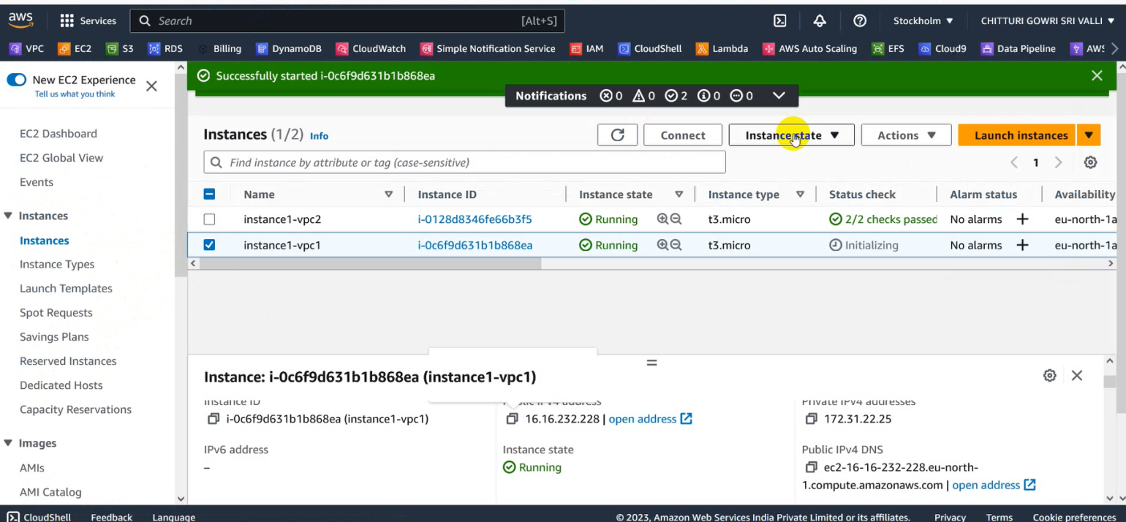

* Hence, in this way instance-2 can be launched

**Service 3: S3**



* Open S3 service and create 2 buckets with the names bucket1-vpc1,bucket2-vpc2 in the same region

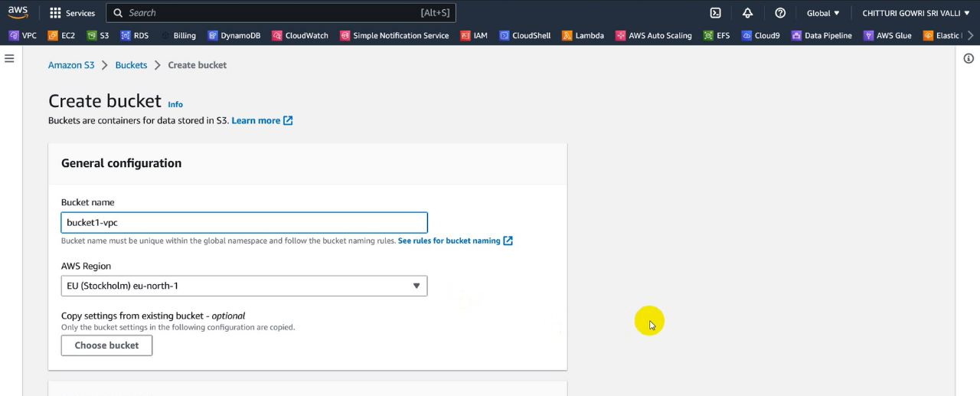

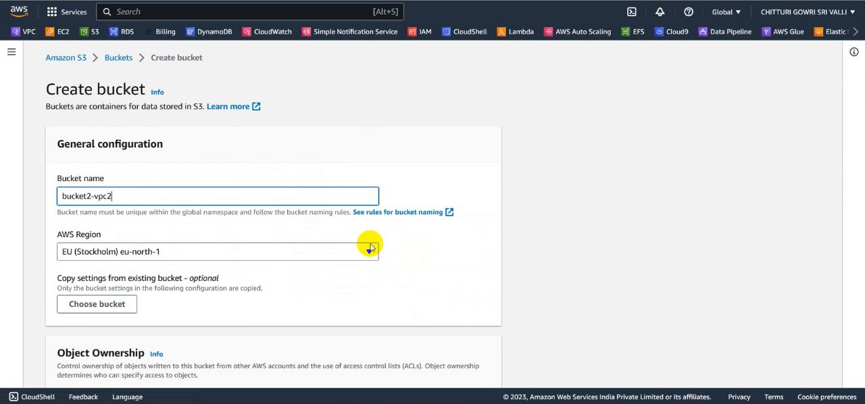

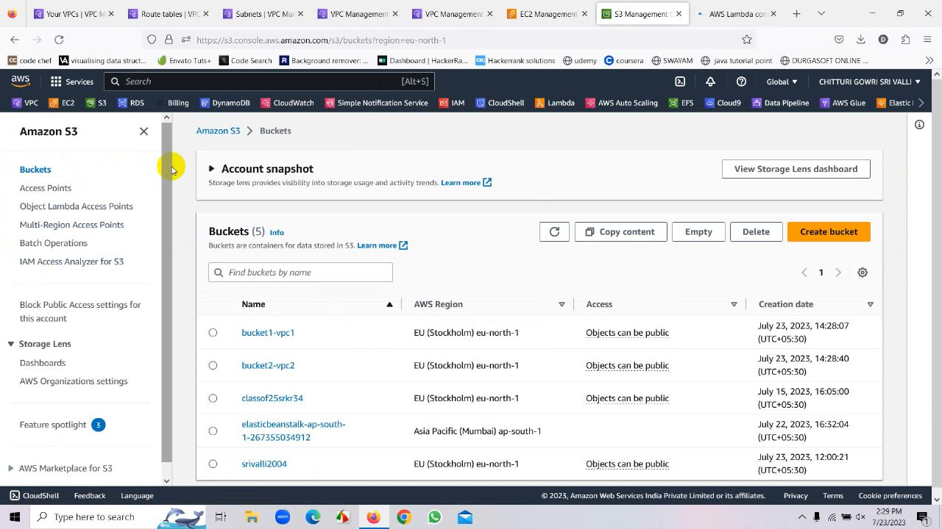

**Service 4: Lambda**



* Go to Lambda Serive
* Now Click on create a function

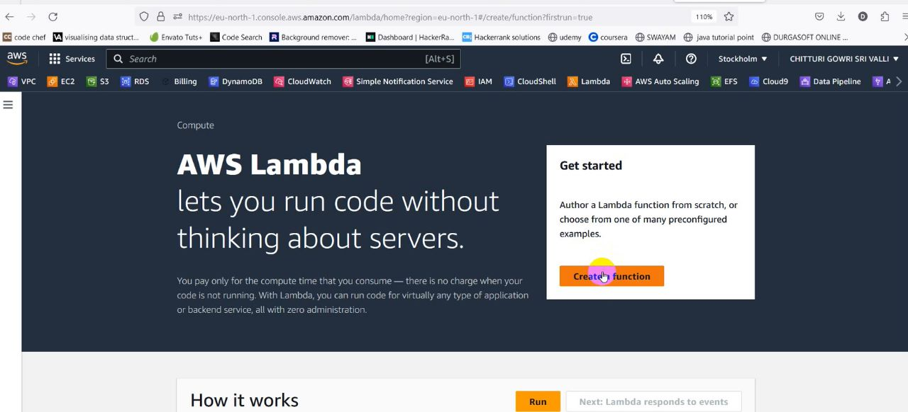

* Name the function as bucket1-bucket2
* Then the function can be created

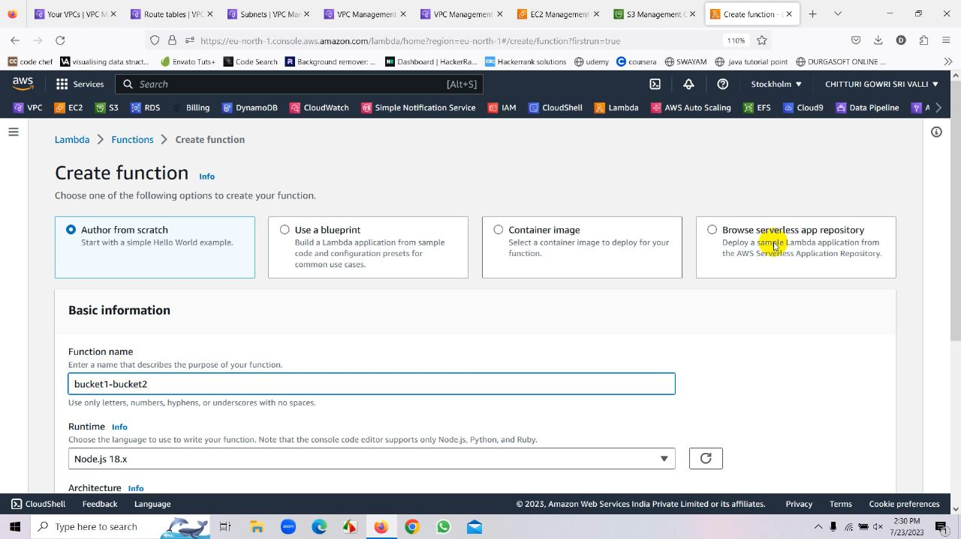

* After creation of the function we have to add the trigger to it

**Sub Service: Trigger**

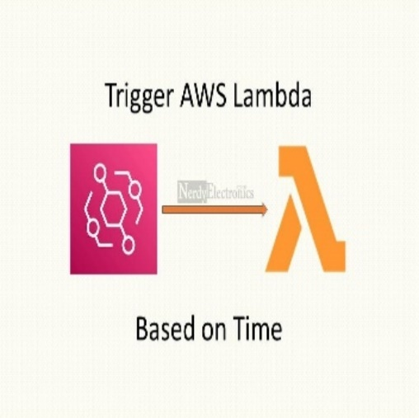

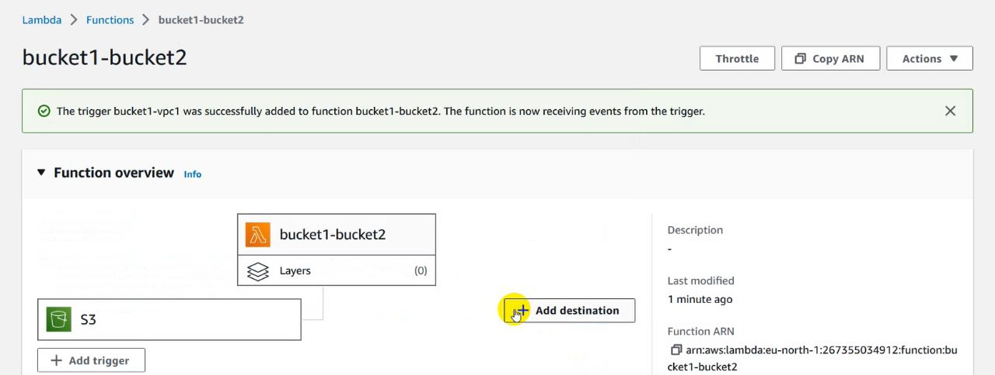

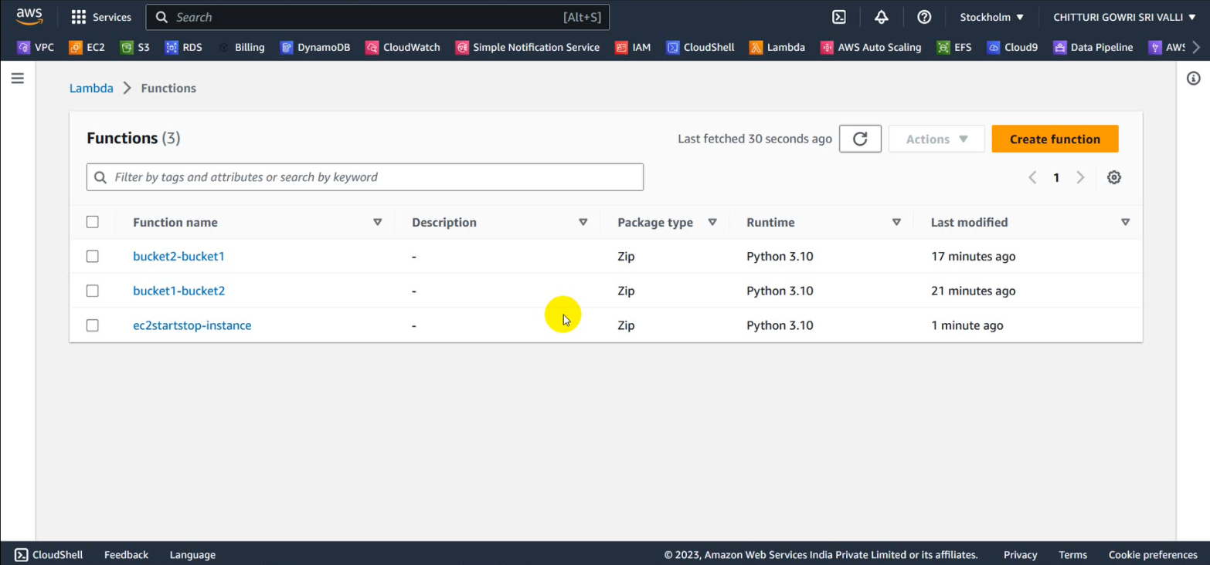

* Here we selected the s3 from the trigger.

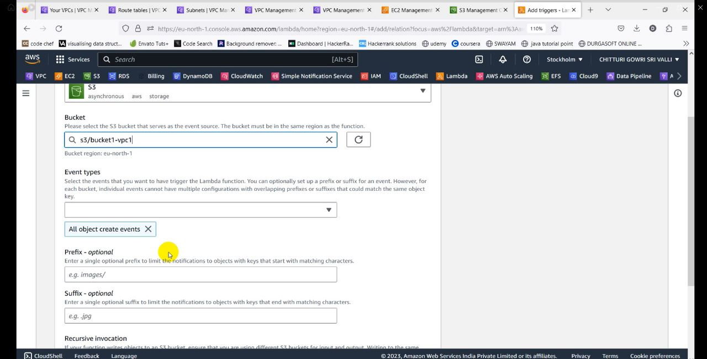

* Now we selected the bucket1-vpc1.Then the bucket can be added

**Sub Service: IAM Users**

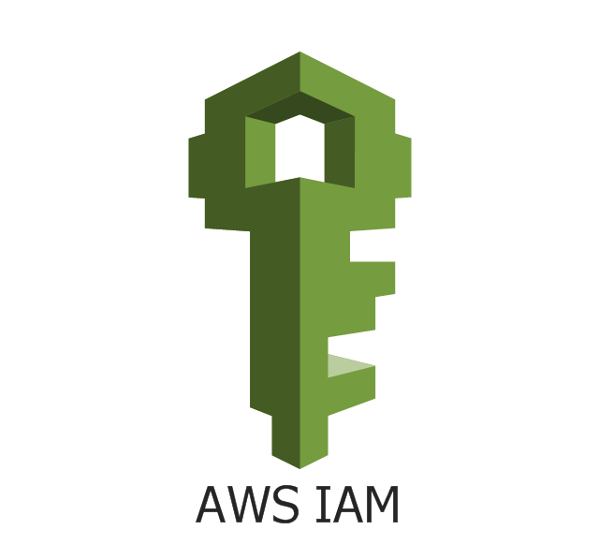

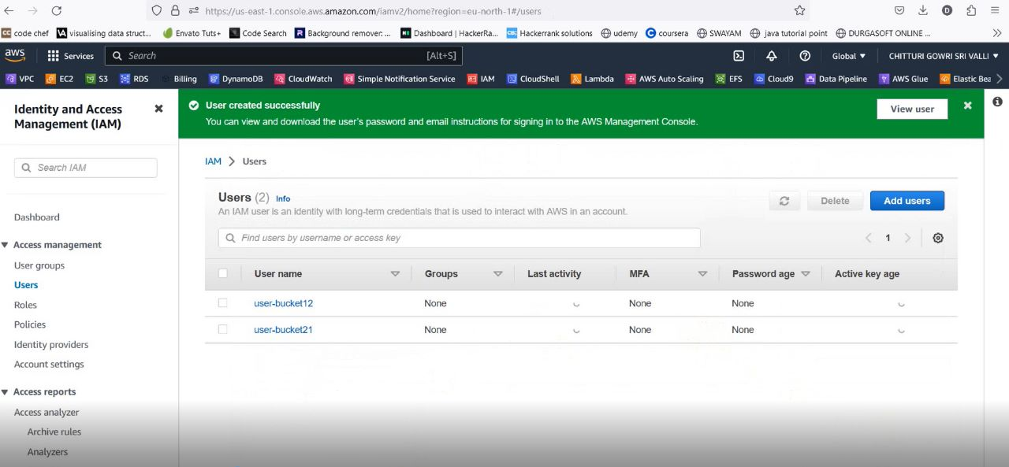

* In the similar way create another function with the name bucket2-bucket1
* Add the trigger to that function with the bucket2-vpc2
* After adding the trigger edit the lambda function with code by changing the bucket name ,Access Key , Secret Key and click on deploy
* Here Access Key and Secret Key are extracted from the IAM user.

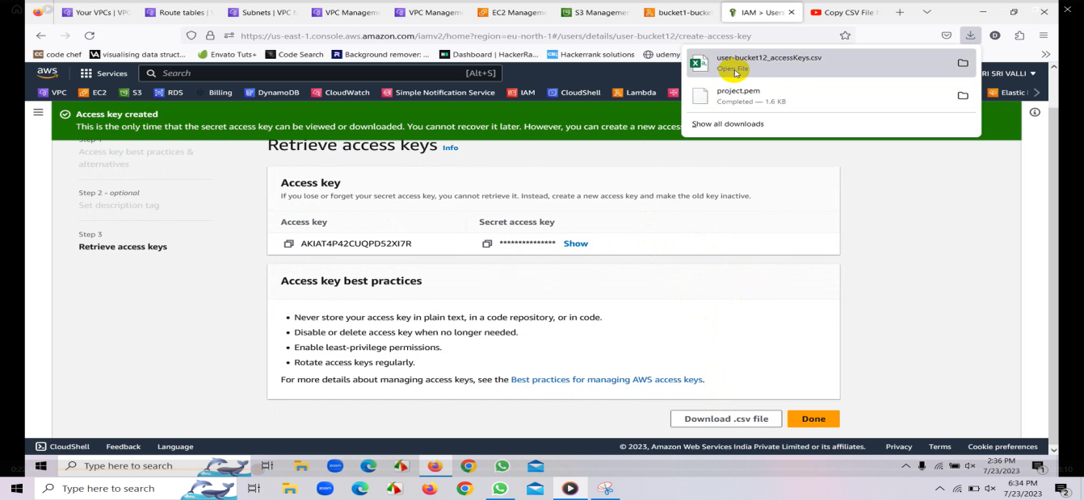

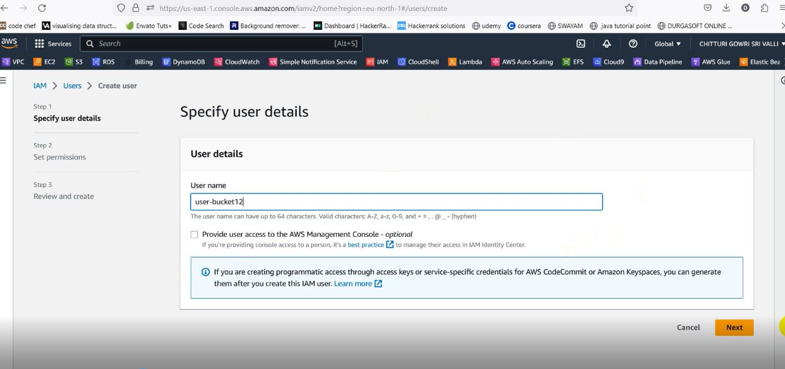

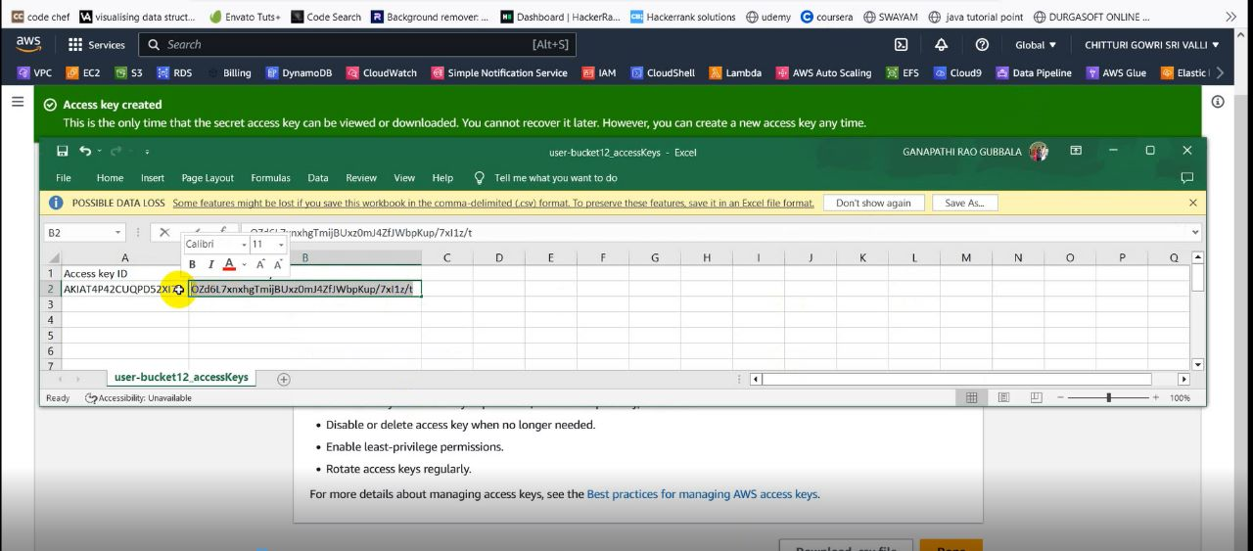

* For this we create an IAM user which is succeeded by a CSV file containing Access Key and Secret Key using these we design a code and deploy it.

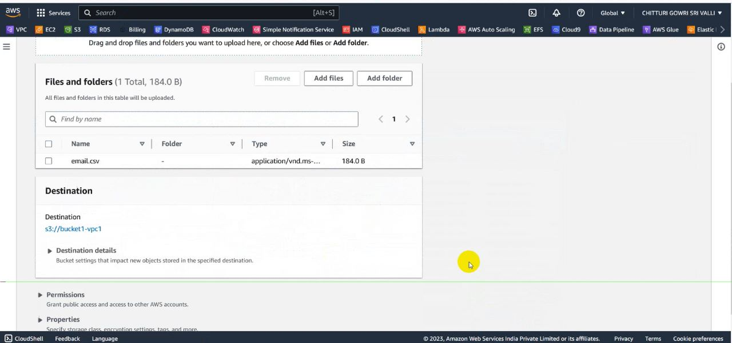

* Now our code is successfully deployed and now if we upload data in one bucket from external tool it will be reflected in another bucket.
* This is transfer of data from source bucket(bucket1-vpc1 or bucket2-vpc2) to destination bucket(bucket2-vpc2 or bucket1-vpc1)

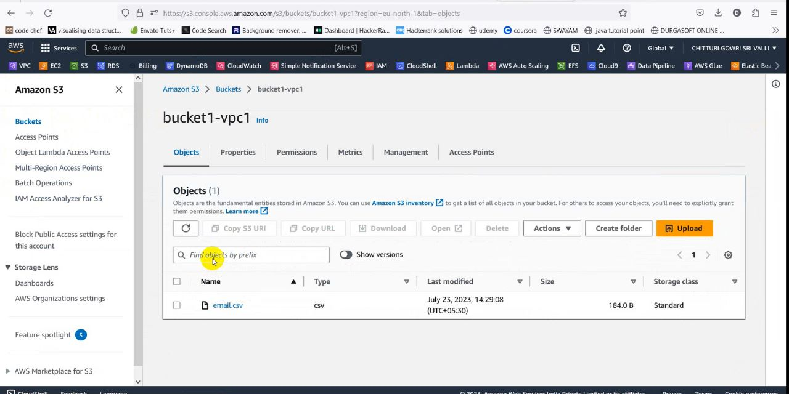

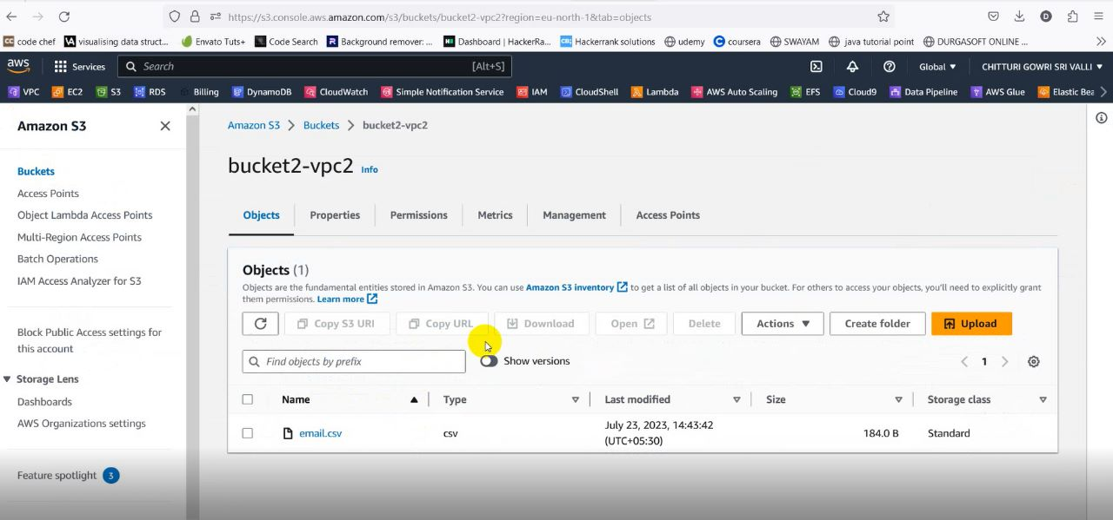

Lambda used for EC2:

* We can stop, start, terminate the instance by creating a function in lambda.
* Go to lambda and create function named ec2startstop-func.

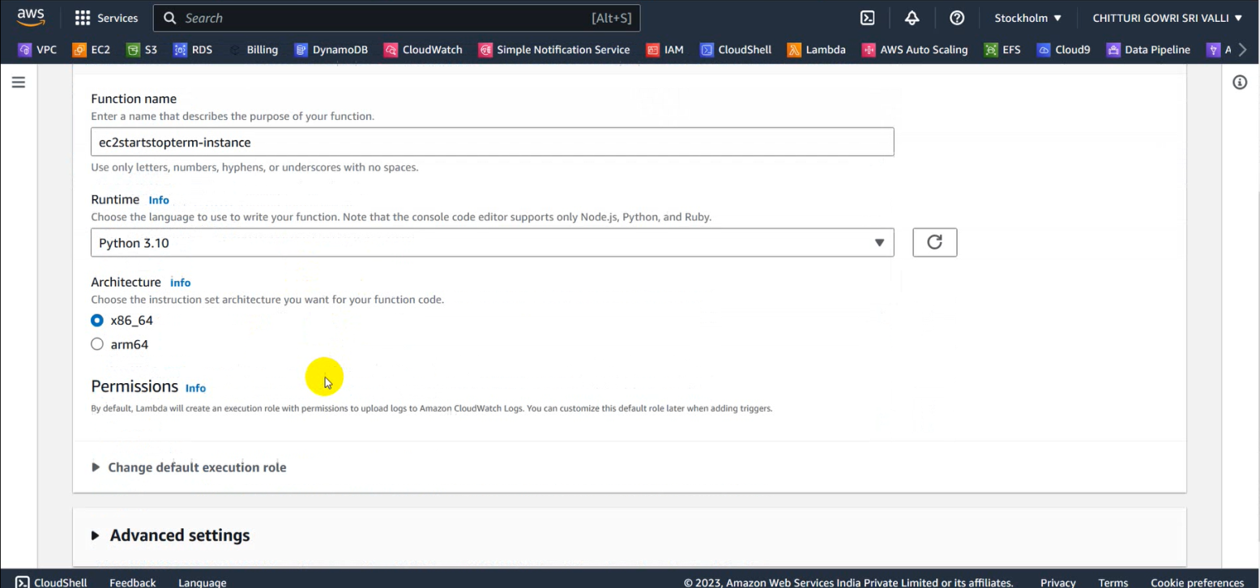

* Now go to code and add the stop instance code by giving our instance ID and region which we want to stop.

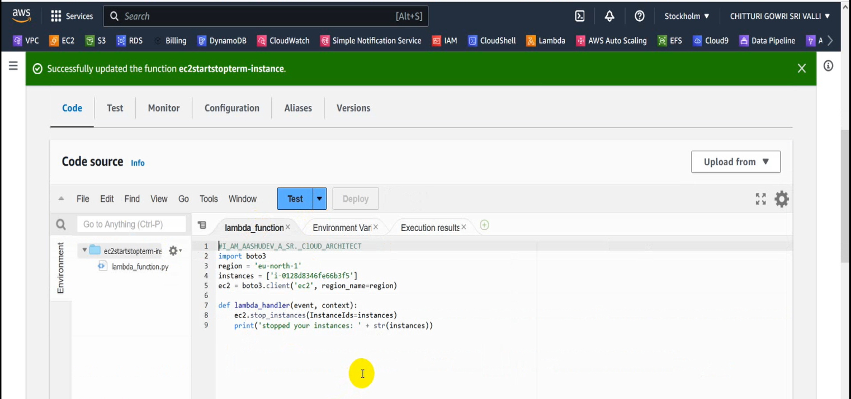

* In this way we can edit the code to stop, start and terminate the instance.
* After giving the code deploy the code and test the code.
* Now check the instance we can see that instance gets to stop, stop and terminate after testing the particular code.

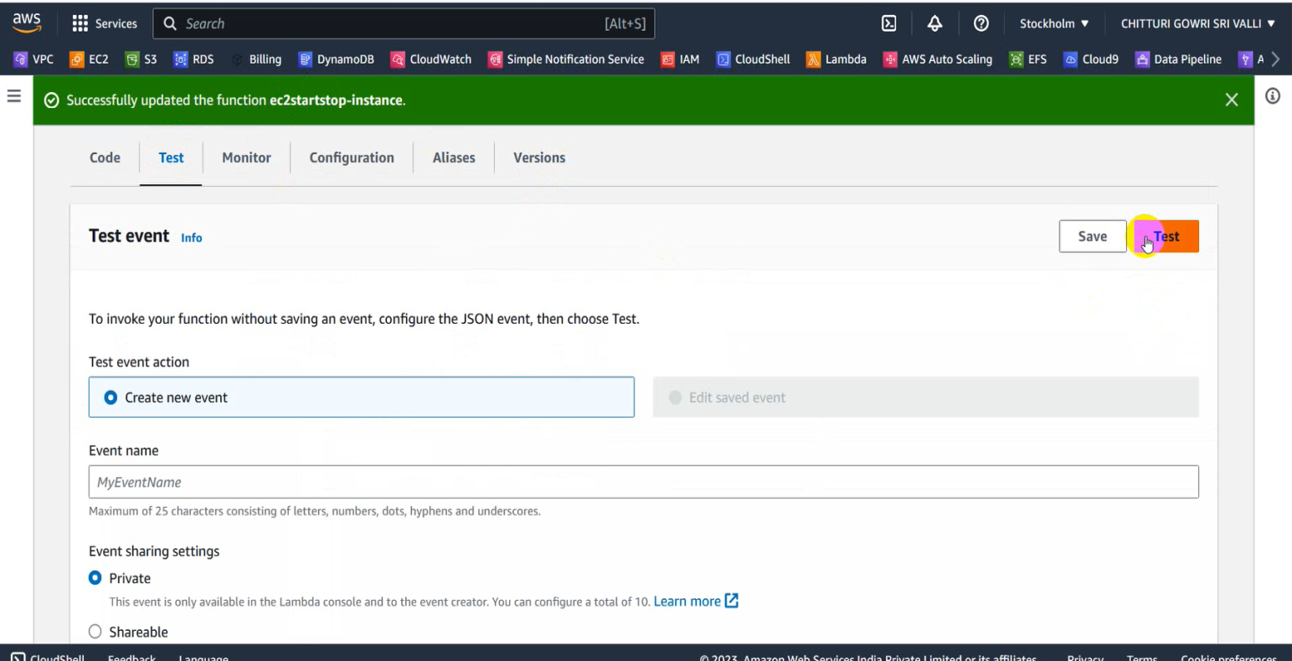

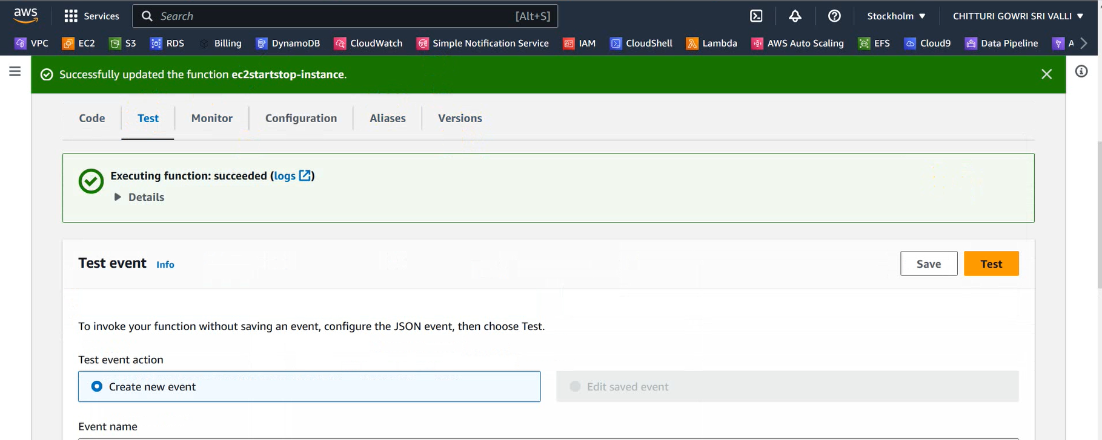

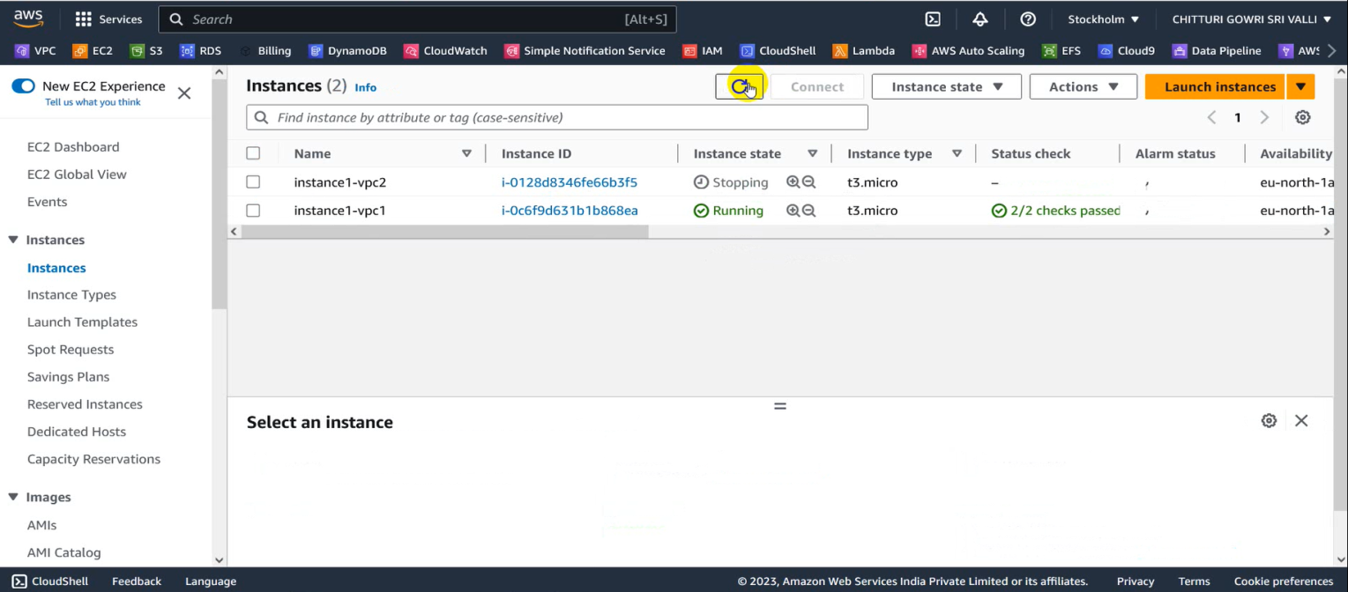

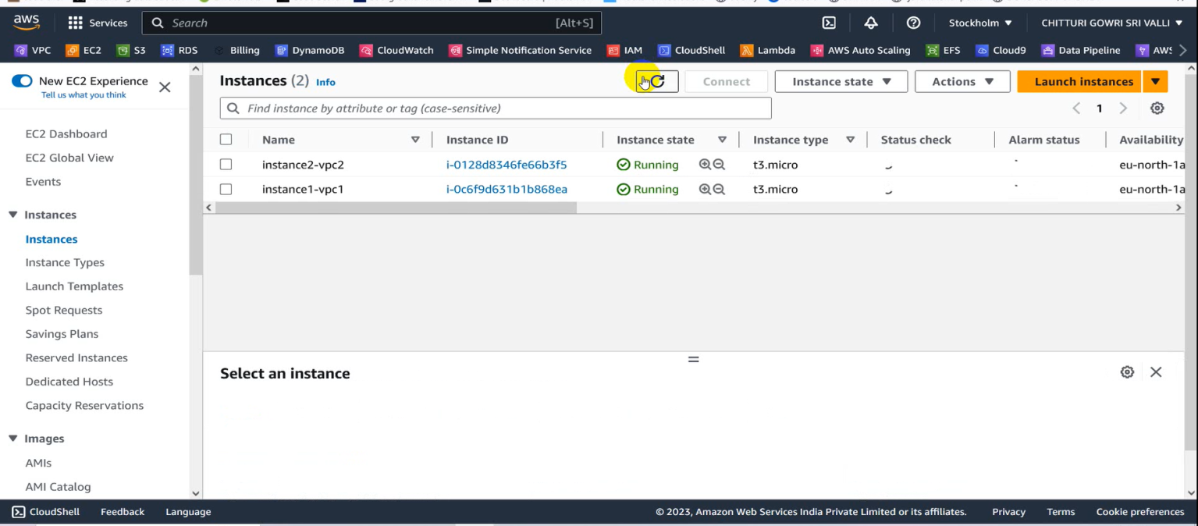

**Service 5: DynamoDB**



* Now we import data from S3 to DynamoDB
* We use a sub service called import from S3 using this we import data from S3 by eliminating duplicates.

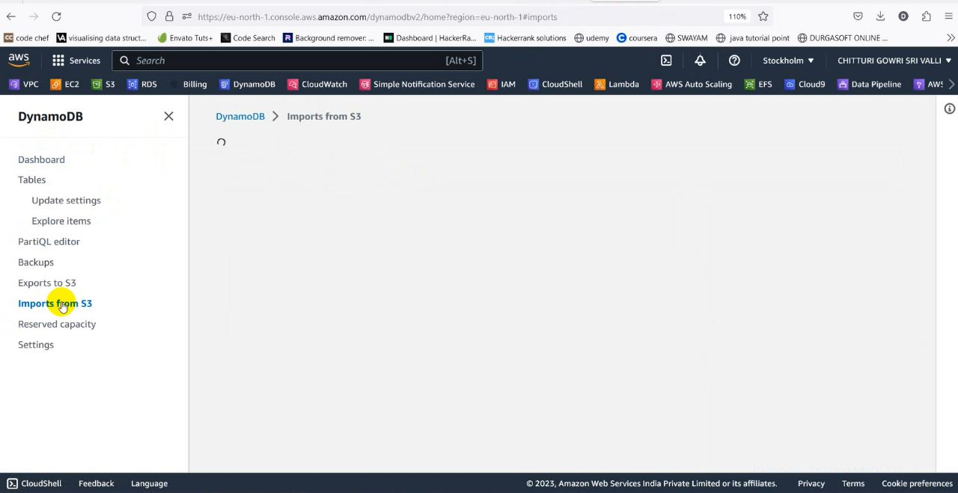

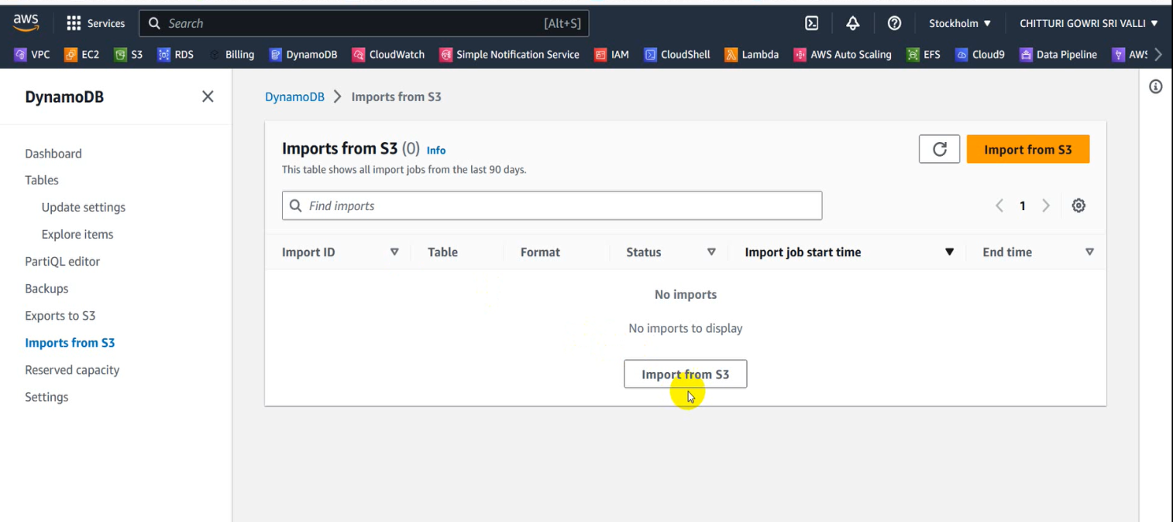

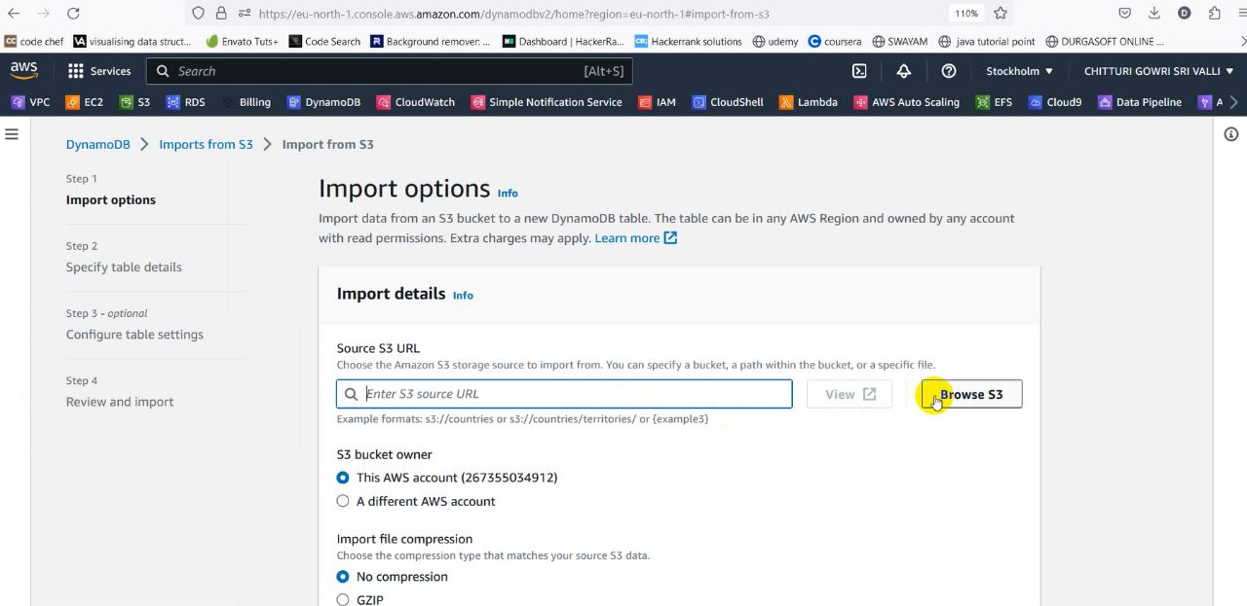

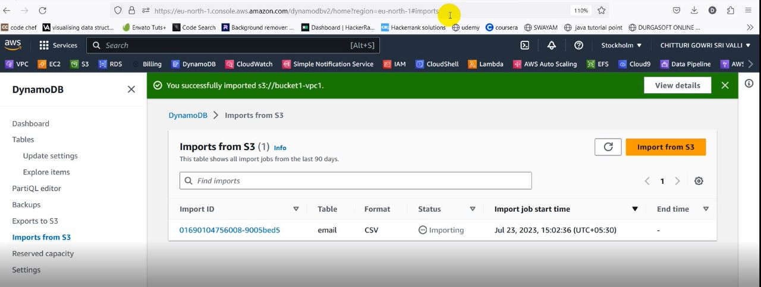

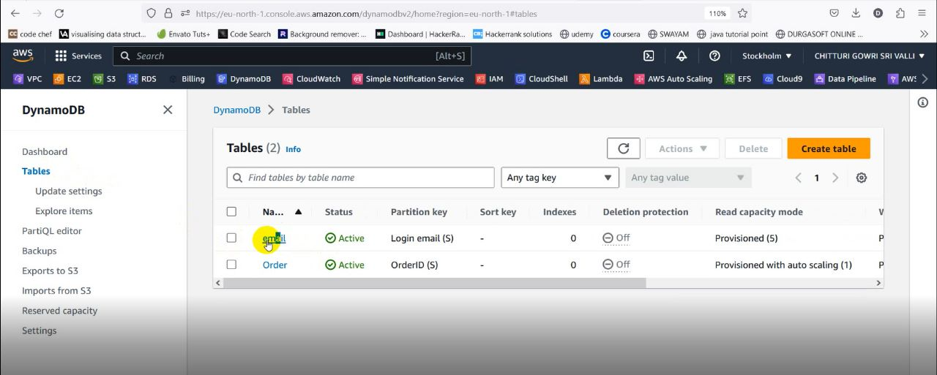

* As it is shown in the above figure the data is imported from the S3 bucket.

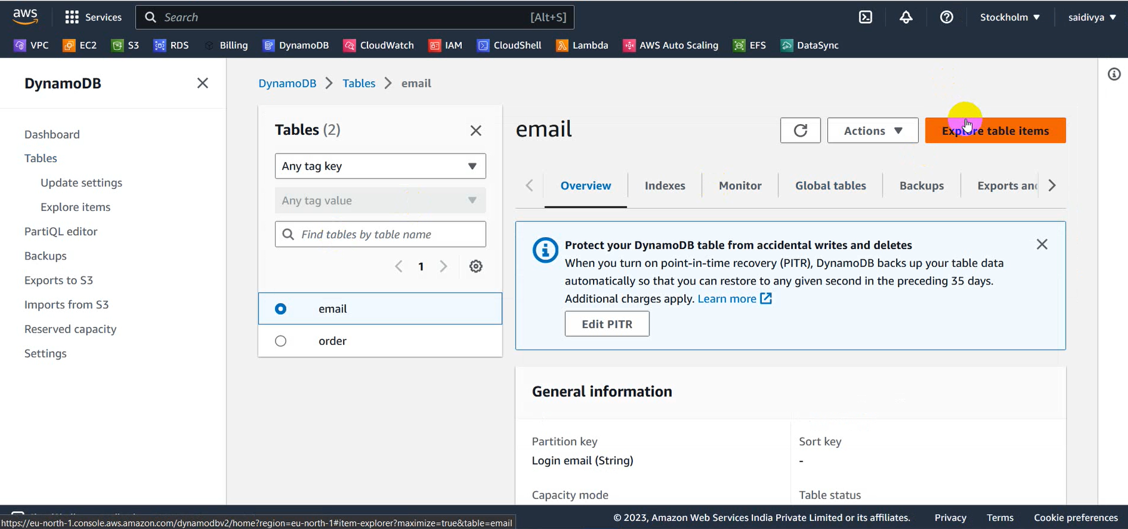

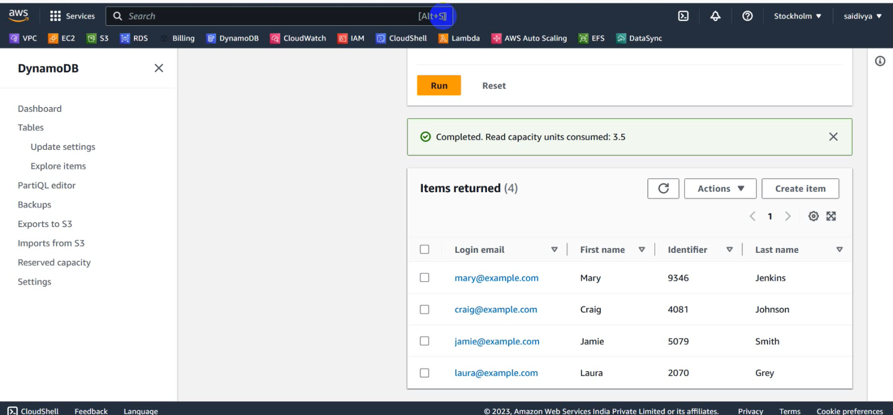

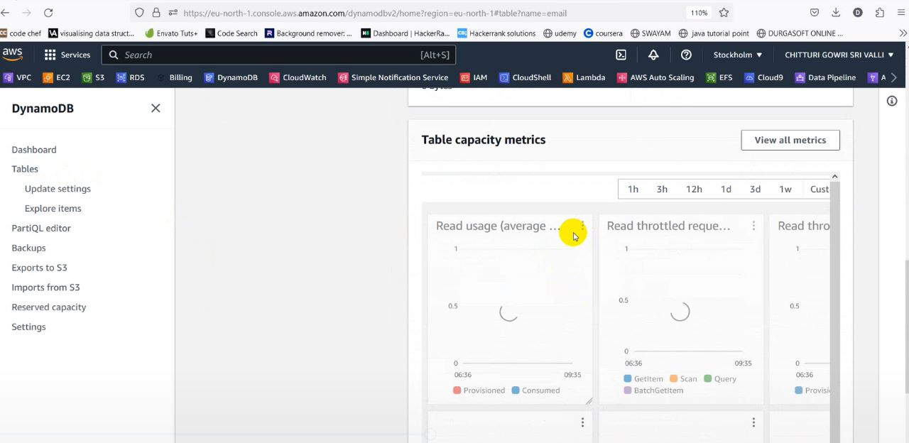

* After this we access the details of the imported data then we redirect to the table capacity metrics.
* Here we enlarge the read usage and we will be redirected to cloud watch.

**Service 6: CloudWatch**



* In Cloud Watch we view Metrics and now move to Graphed Metrics.
* Here we create an alarm using the bell icon in Provisioned Read.

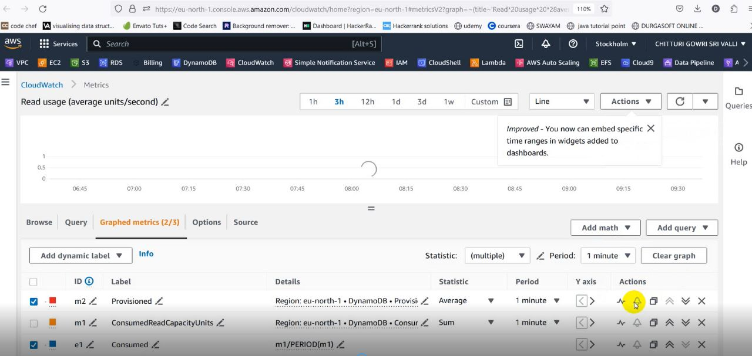

* Now we Specify our metric conditions.

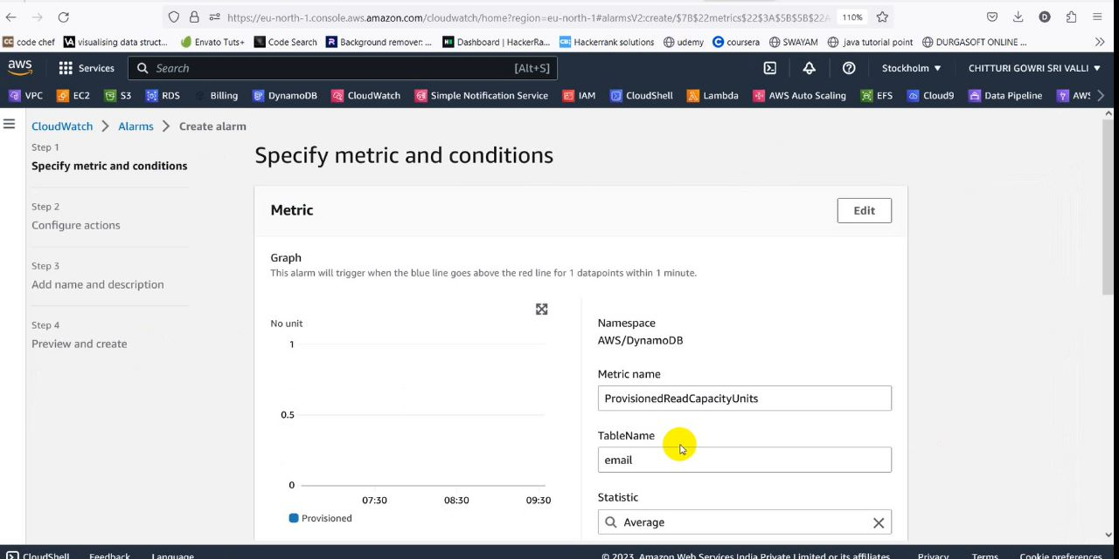

* Now here we provide a Threshold of our comfort.
* Now we will create an alarm topic and we will send request to emails.
* After this we view the subscribers in SNS.

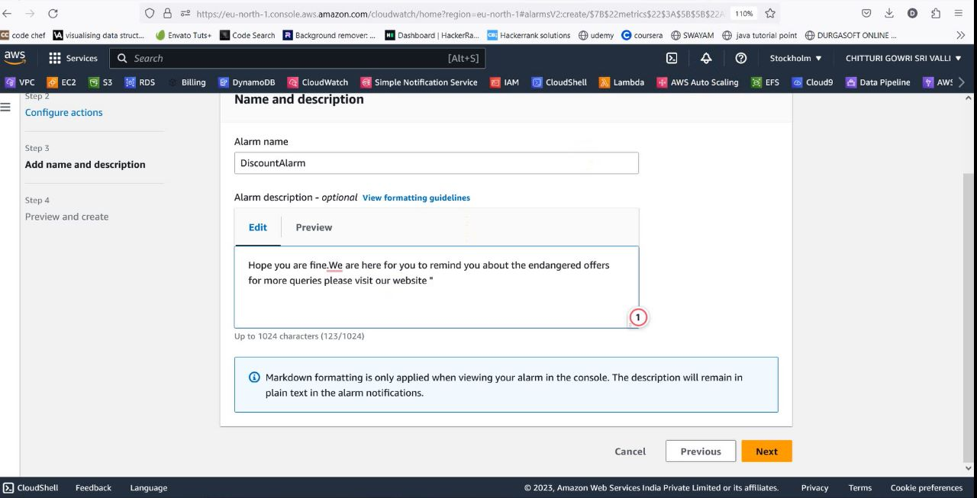

* Now if our threshold limit is not crossed an email will be sent to the subscriber intimating some issue.

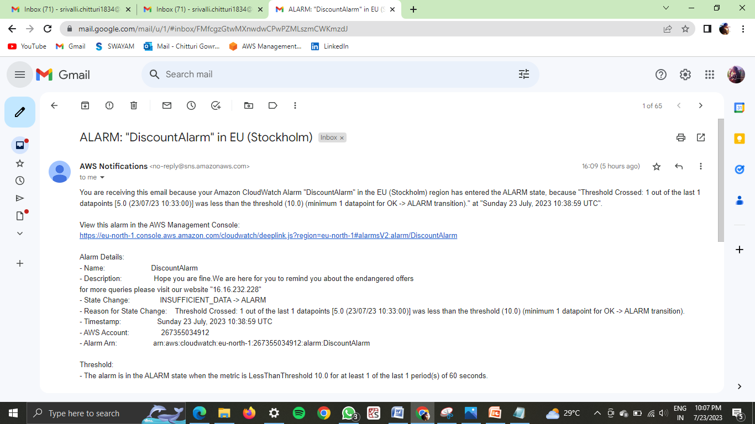

**Service 7: Simple Notification Service (SNS)**



* Now we view or Alarm topic in SNS console.
* Here we view our subscribers who subscribed for our alarm topic for which we have sent.

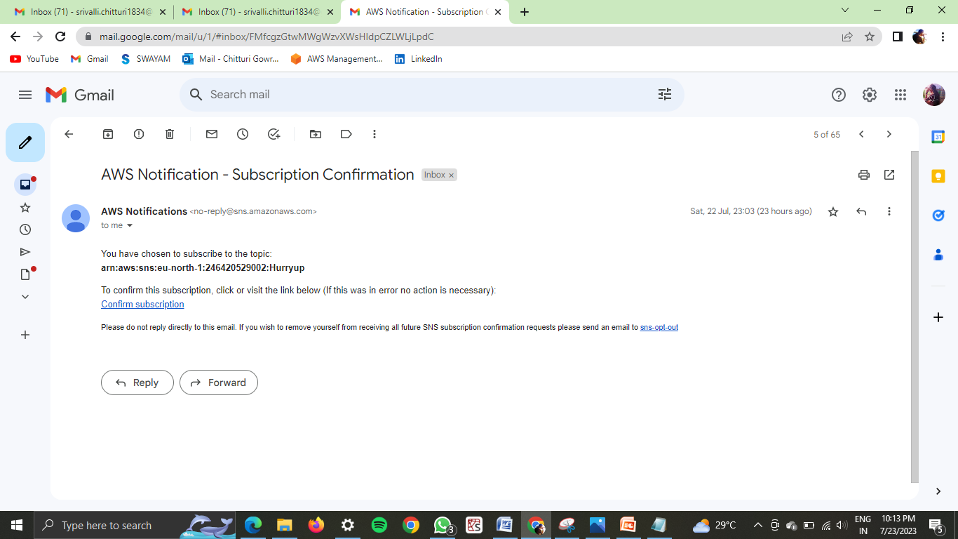

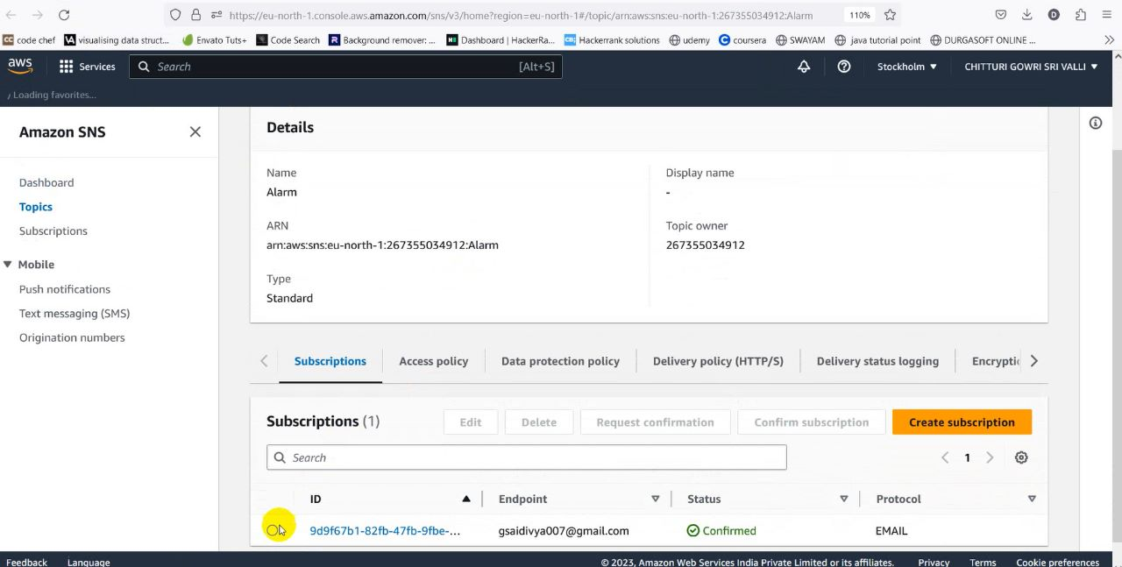

* Now we can publish a message to our subscribers.

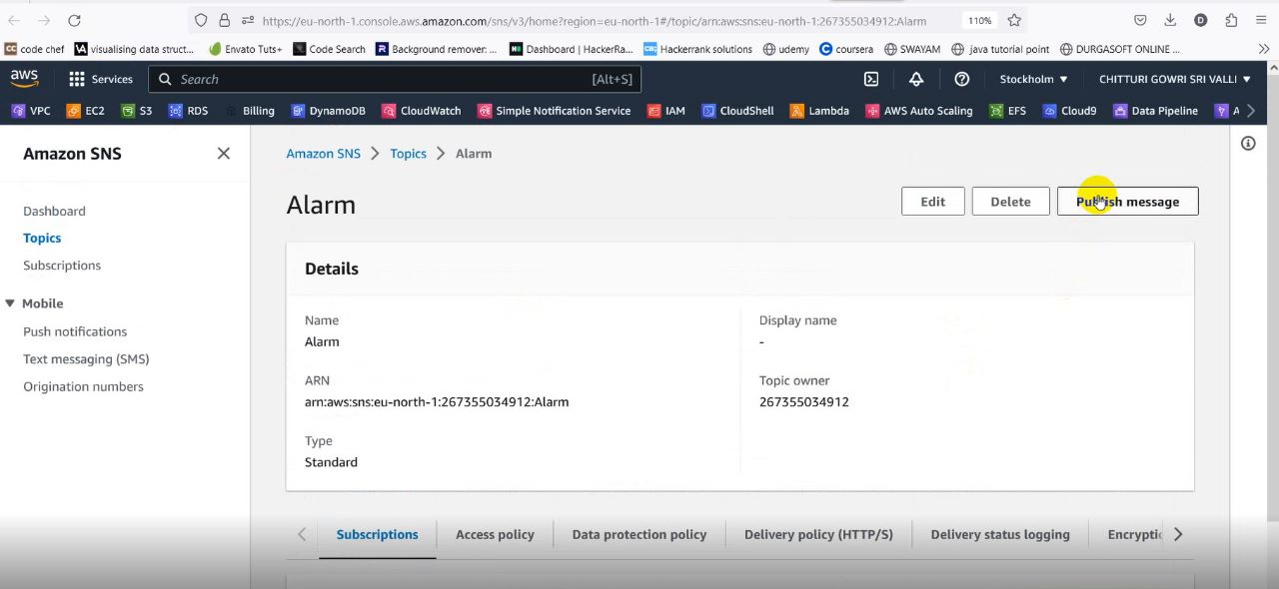

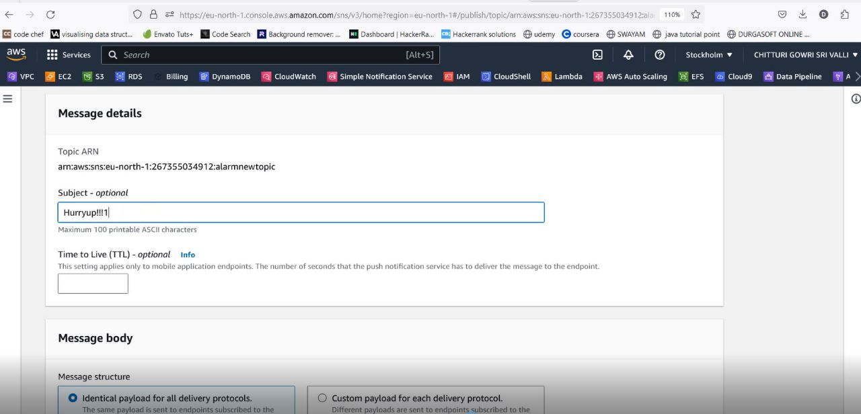

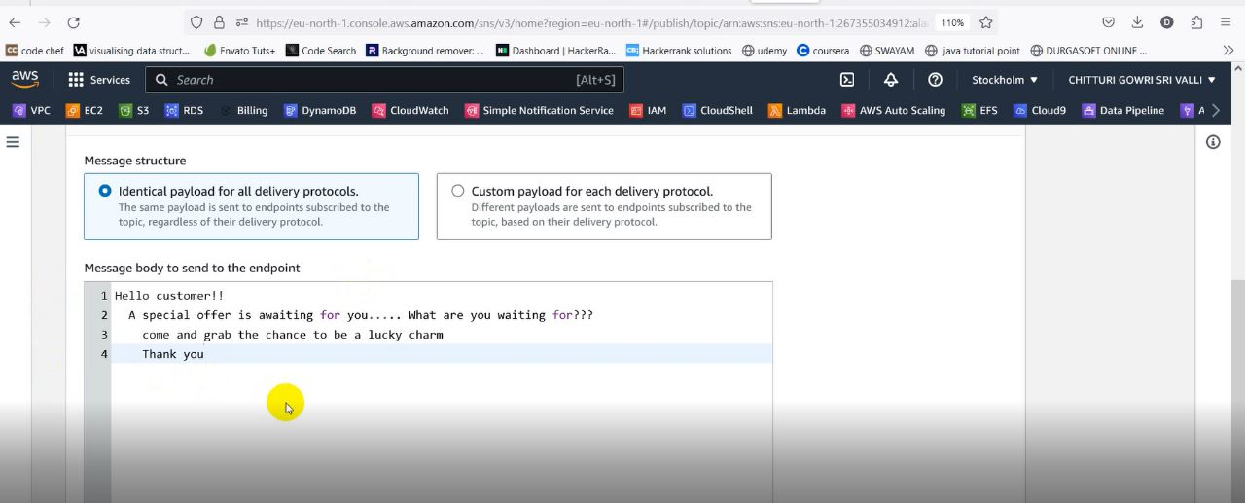

* Now our message is published to our subscriber.

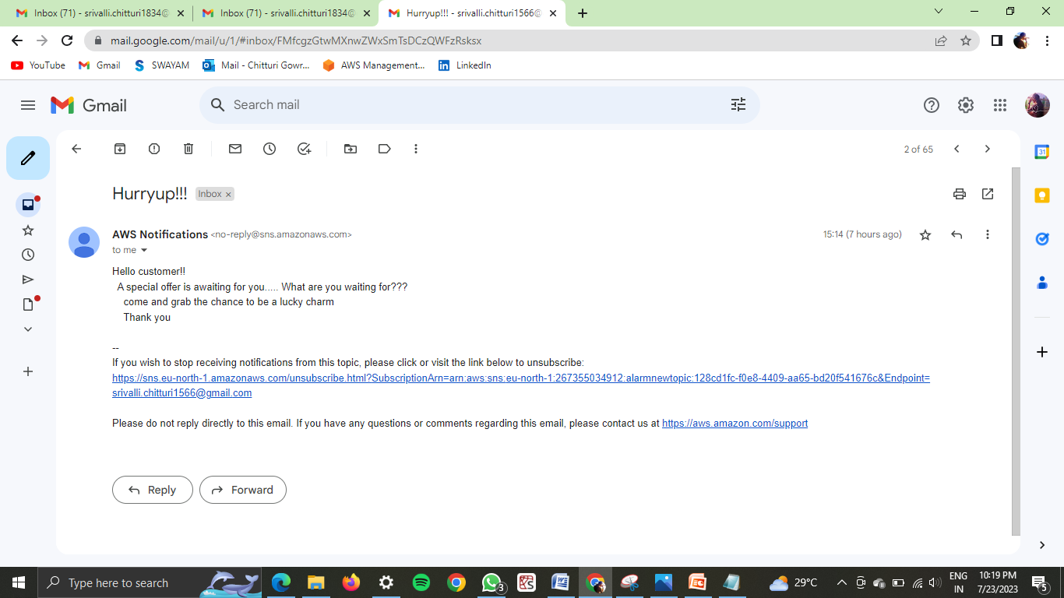

**Service 8: ELB**

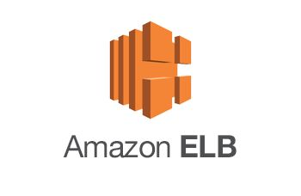

* Create a load balancer in EC2
* Name the load balancer as bootstrap

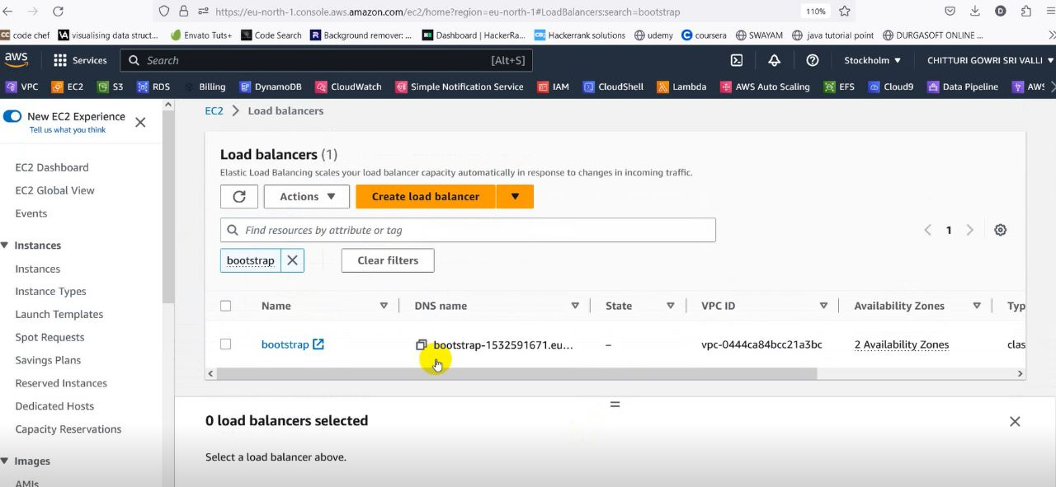

* Click on the load balancer and check the status of instance is in-service or not

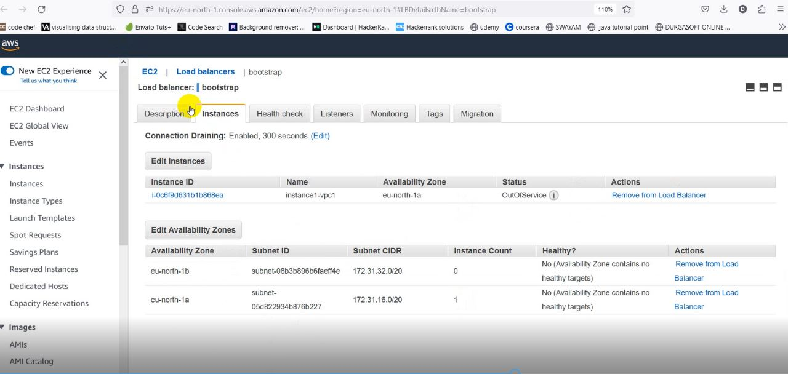

* If the status of the instance is still Out of service then we have to edit the inbound rules of the security group

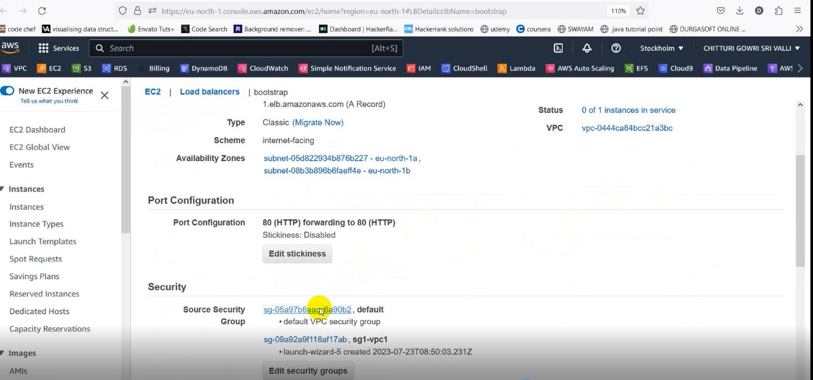

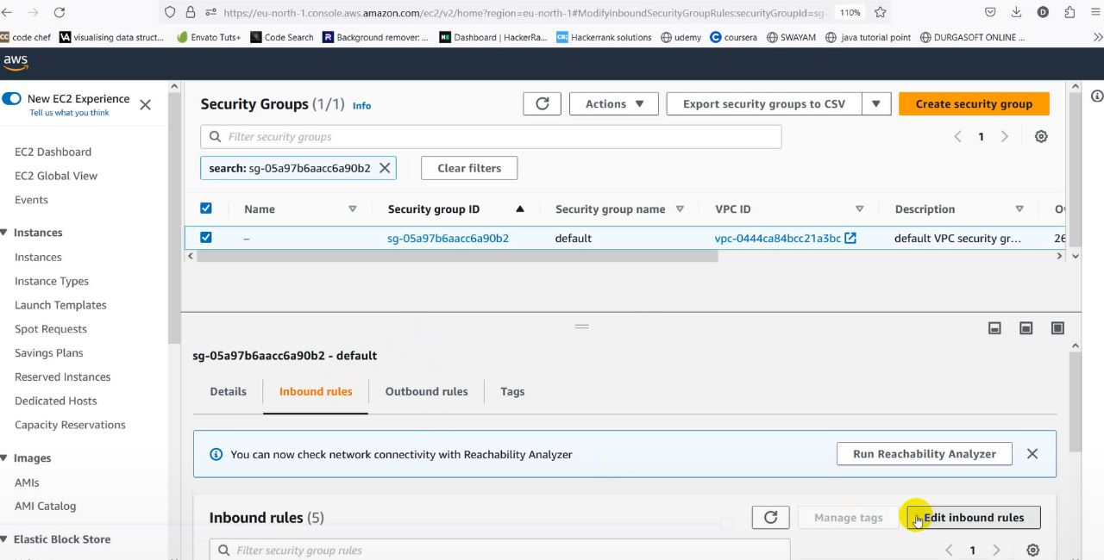

* Add the security group rule All traffic and Anywhere

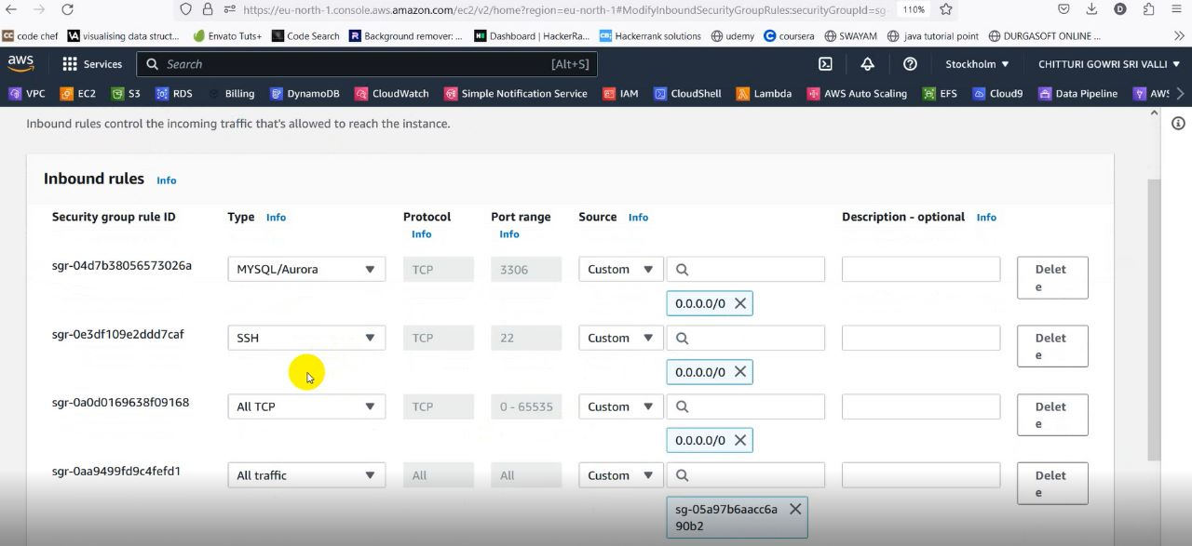

* After editing the inbound rules of security group, again check the status of the instance
* Here we got the instance in in service

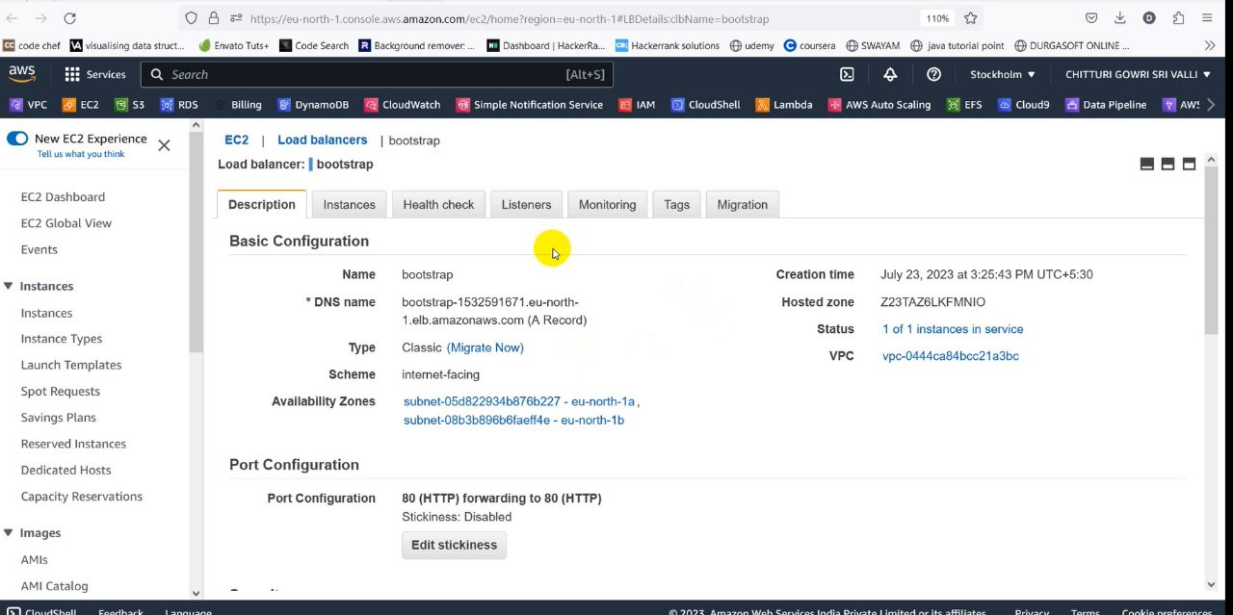

**Sub** **Service: Boot Strapping**



* While we creating the instance1 , we have uploaded a file in the advanced details which is used to create a website
* From the previous step,as we get the status of the instance is inservice,we have to copy the public Ip address of instance1 and paste it in a new tab
* Then we can reach our website

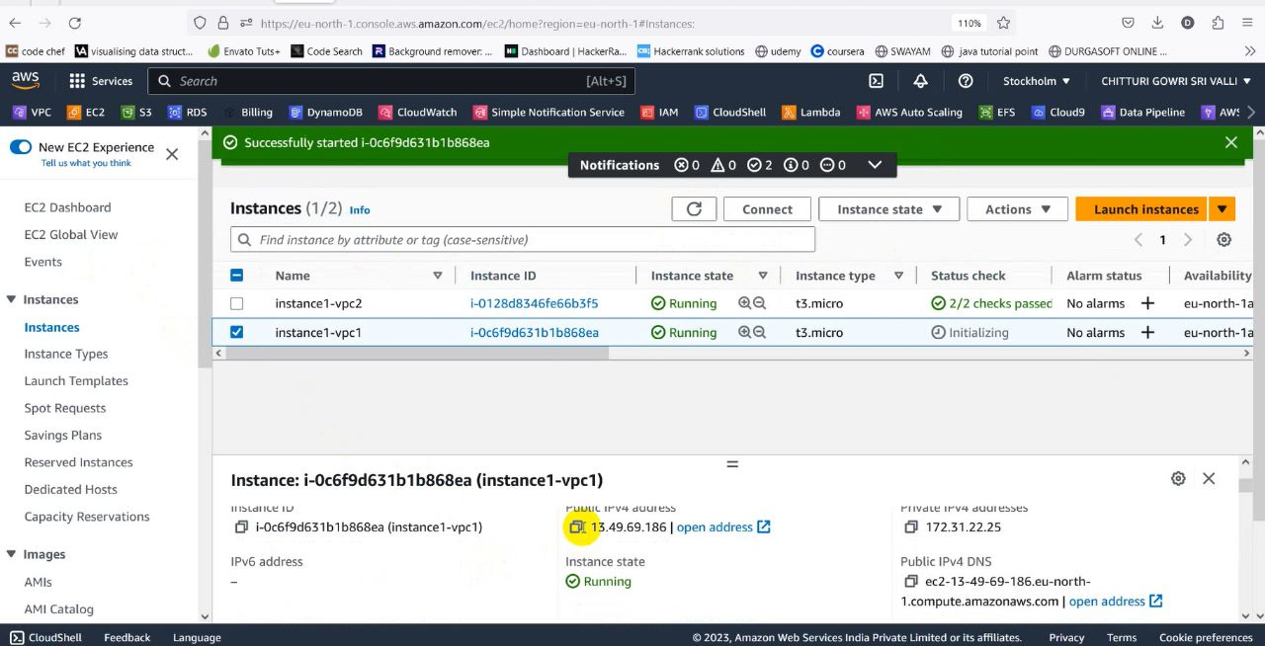

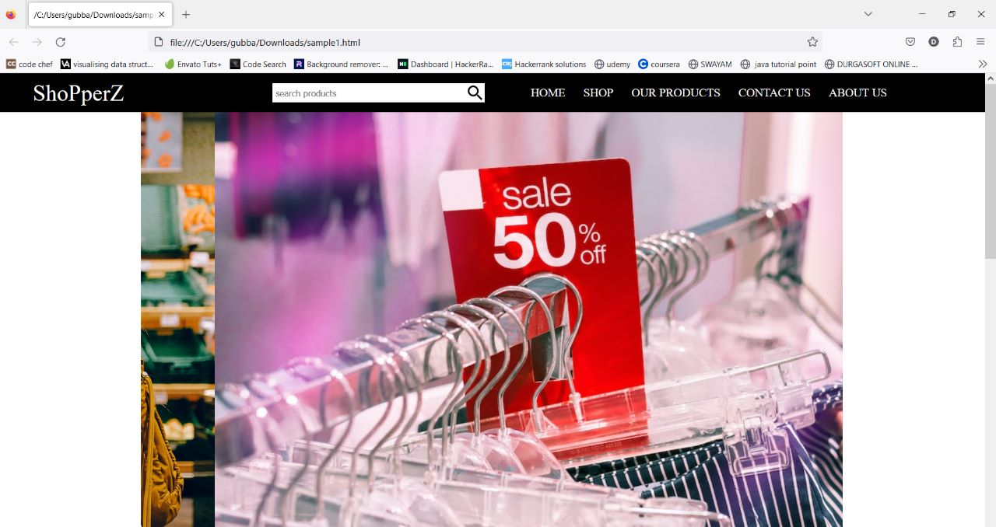

**Sub Service:Elastic Ip**



* Click on EC2and go to Elastic Ip
* Now click on alloacte elatic IP address and create it
* Then associate this elastic Ip address.This Elastic Ip is used to avoid 404 Error in our created website

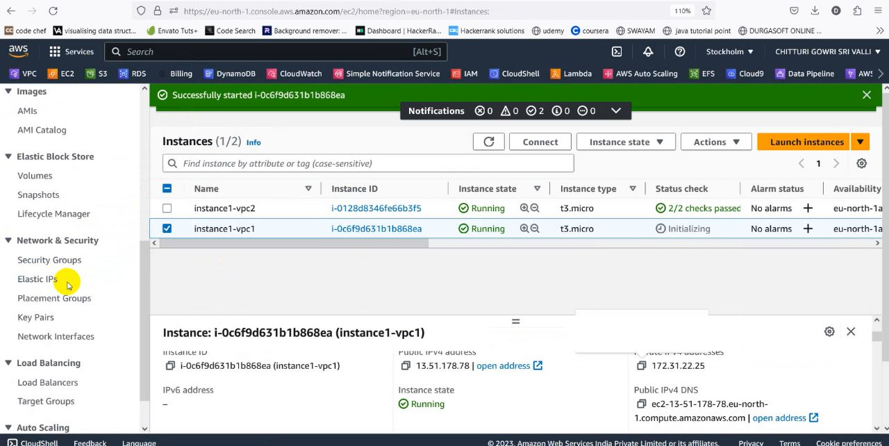

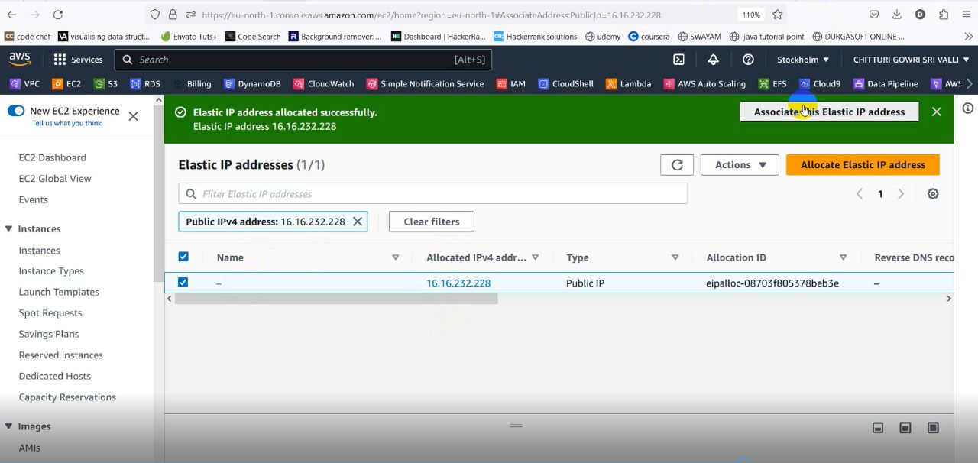

**Service 9:Relational Database Service[RDS]**



* Go to RDS and click on create a database

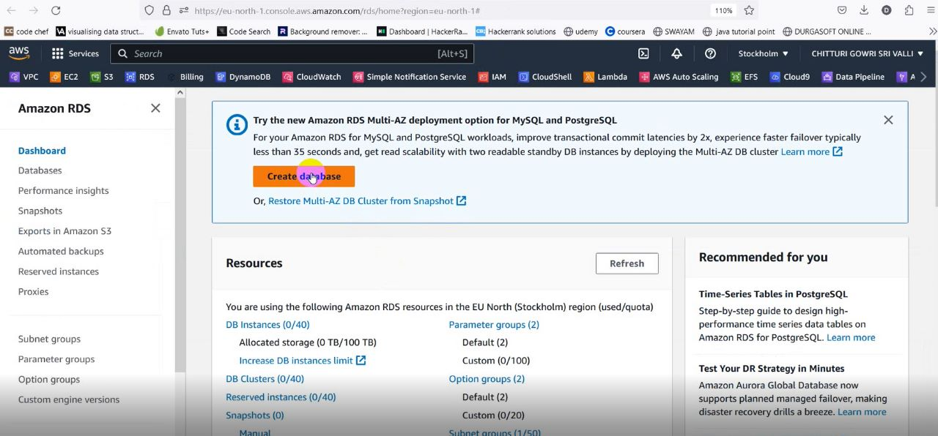

* Create a database using MySql Engine by using default vpc and scurity groups

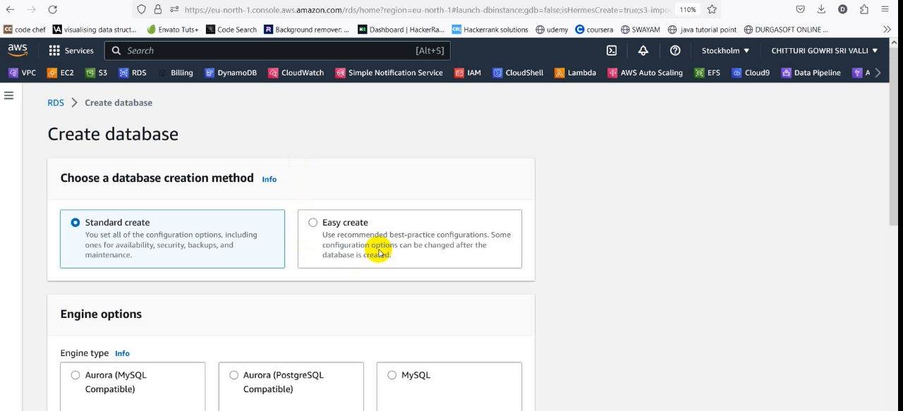

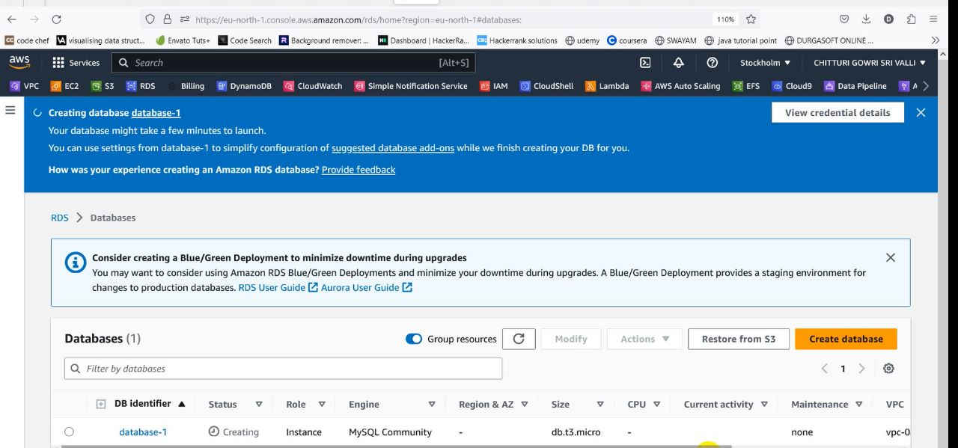

* Here we created the database with name database1

**Service 10:AWS Glue**



* To import the data from S3 to rds ,we are using the third party tool which is known as AWS Glue service
* Go to AWS Glue and create Crawlers with the name s3-rds-crawler
* Then we add a data source i.e S3 bucket1-vpc1

**Sub Service: Crawler**



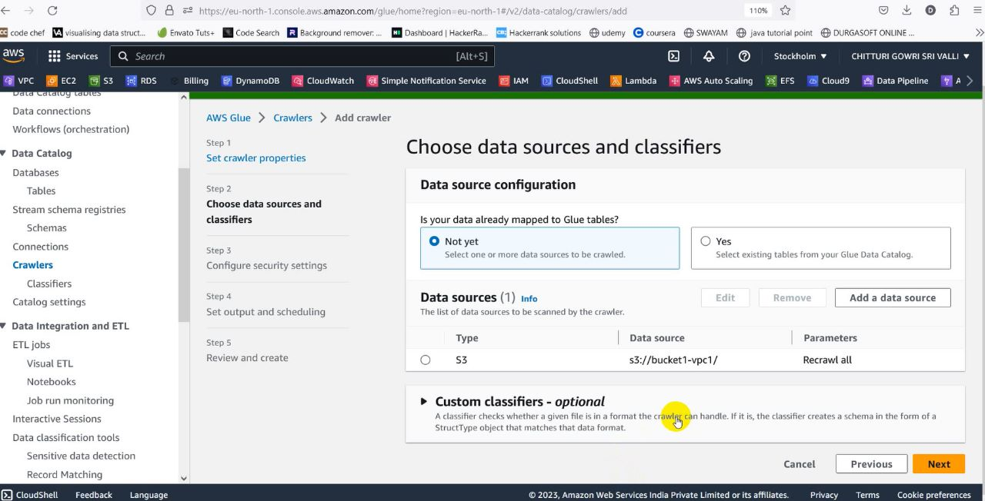

* Then we choose an existing IAM role which is created using permissions s3fullaccess,rdsfullaccess,glue

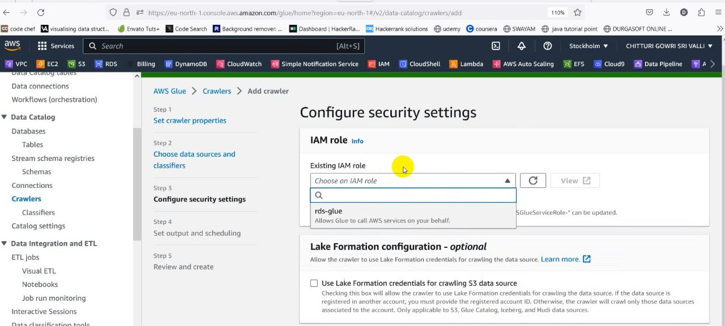

* After creation of the crawler,click on run

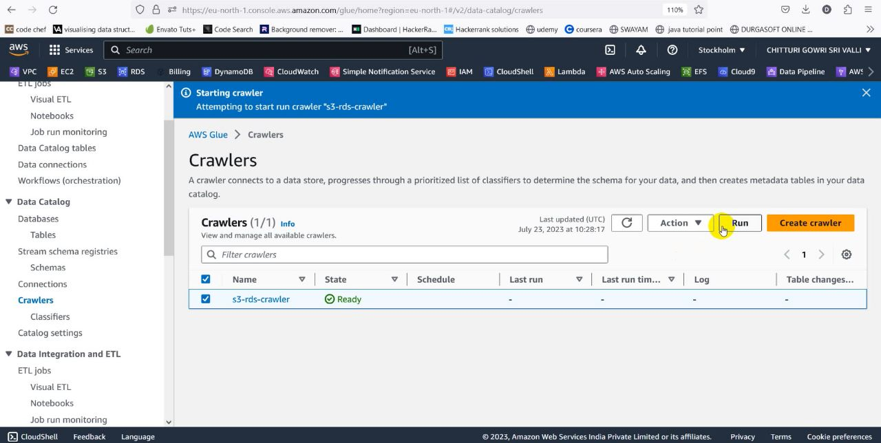

* Meanwhile create a database with name temp1
* After the successful execution of crawler ,the tables which we want to import from S3 bucket will be imported into the tables of database created in the AWS Glue

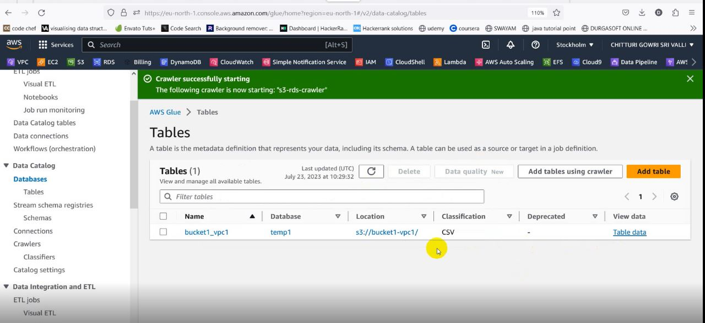

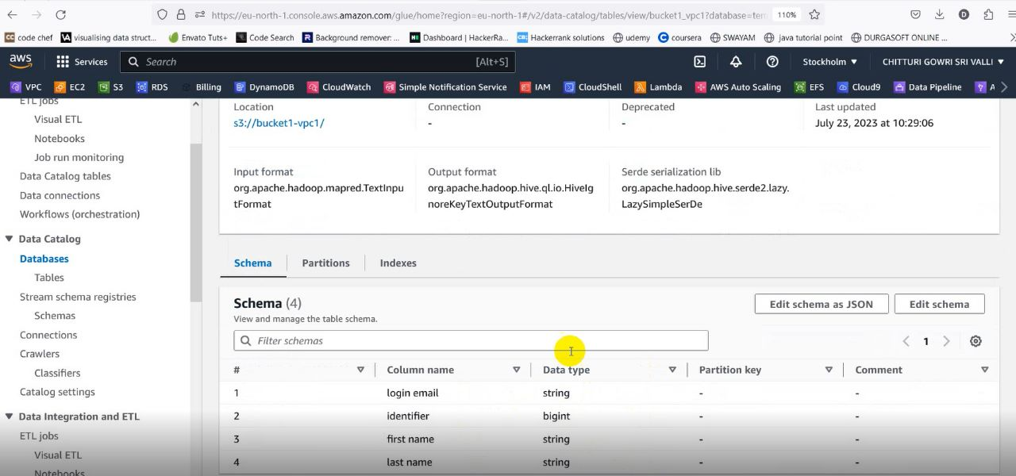

**Service 12:IAM**



* IAM is used in tranfer of data within two buckets in the same region

On behalf of Lambda.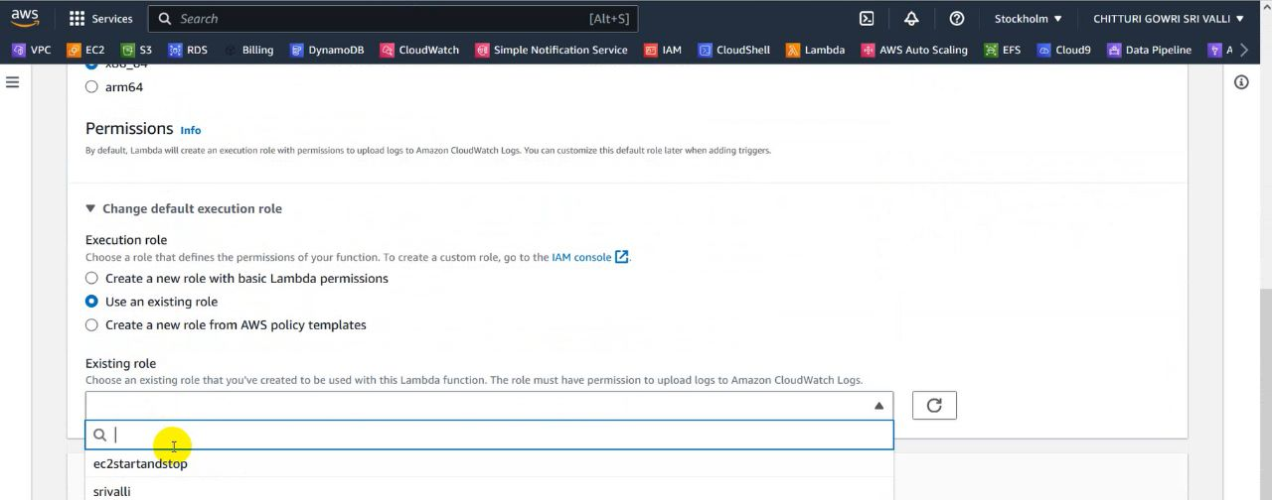

* A role created on behalf of EC2 using lambda function to control the state of an instance by deploying the code in lambda function

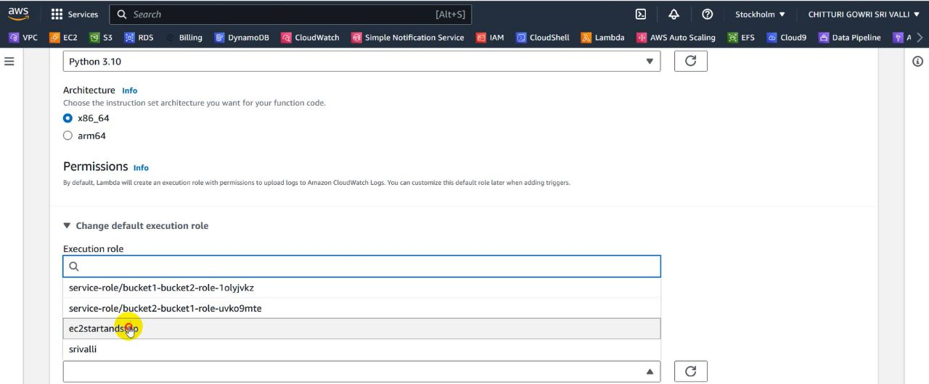

* In AWS Glue,while we creating the crawler we will give a role by giving the permisiions s3fullaccess,rdsfullaccess,glue

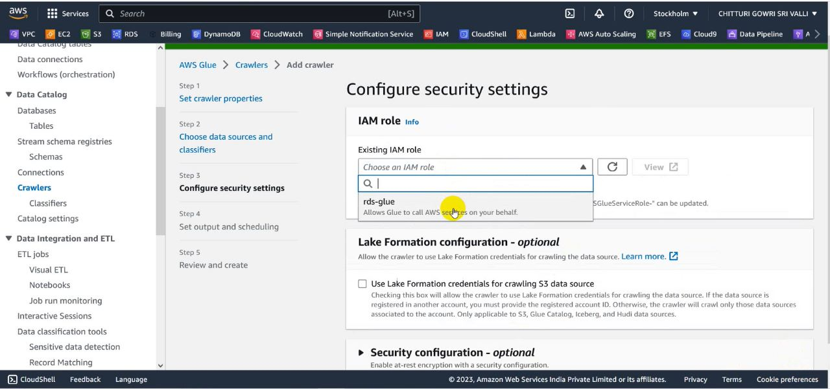

**Conclusion:**

So,This is our Architecture and implementation in detail the total senario explains how it can transfer data between two Buckets in same region and storing this data in DynamoDB by eliminating duplicates. This fine Architecture gives deep insights on how to manage the large sets of data. A point to be noted here is that the Architecture not only focused on how the data is preside over but also concentrates on the process of interaction with users and this all results in maintaining a trivial line of business.

**Ultimately the outcome is :**

**A real time small scale application (Mart)**